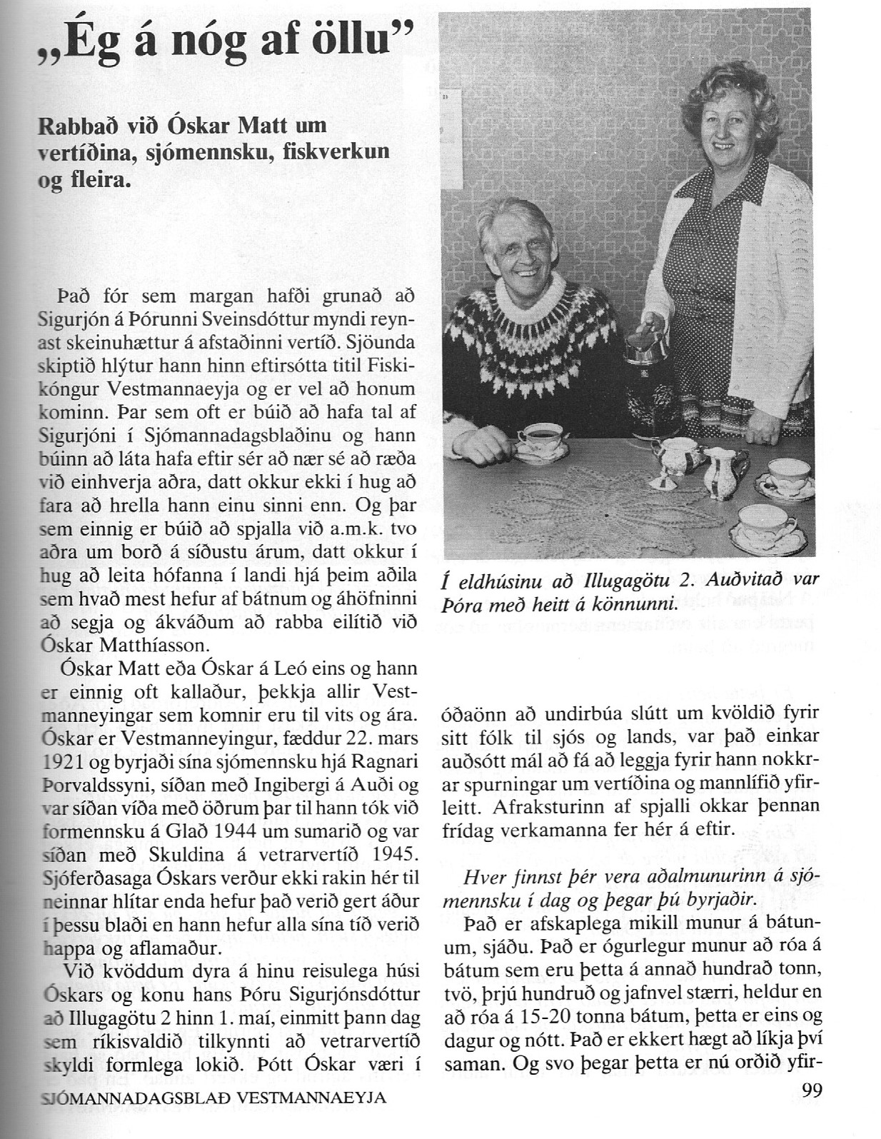

---------------------------------------------------1------------------------------------------

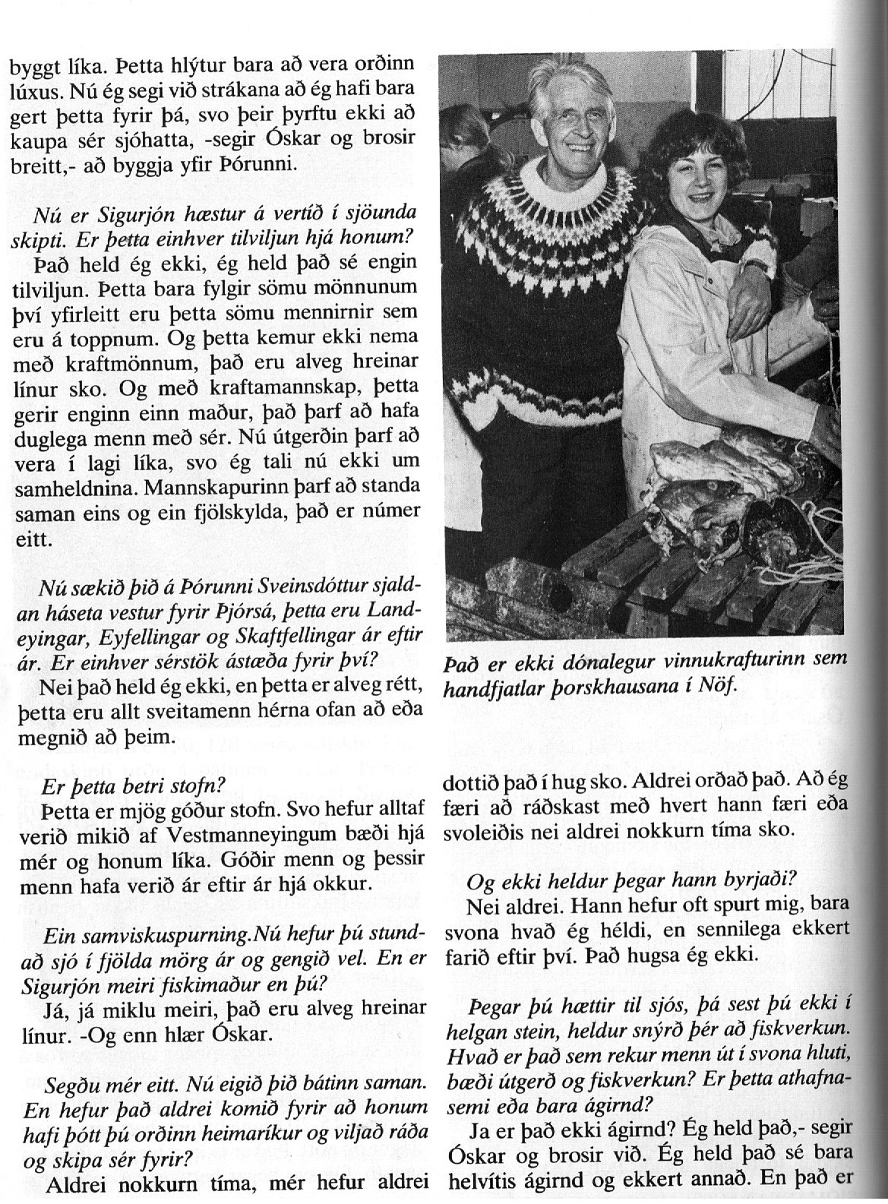

-------------------------------------------------2----------------------------------------------

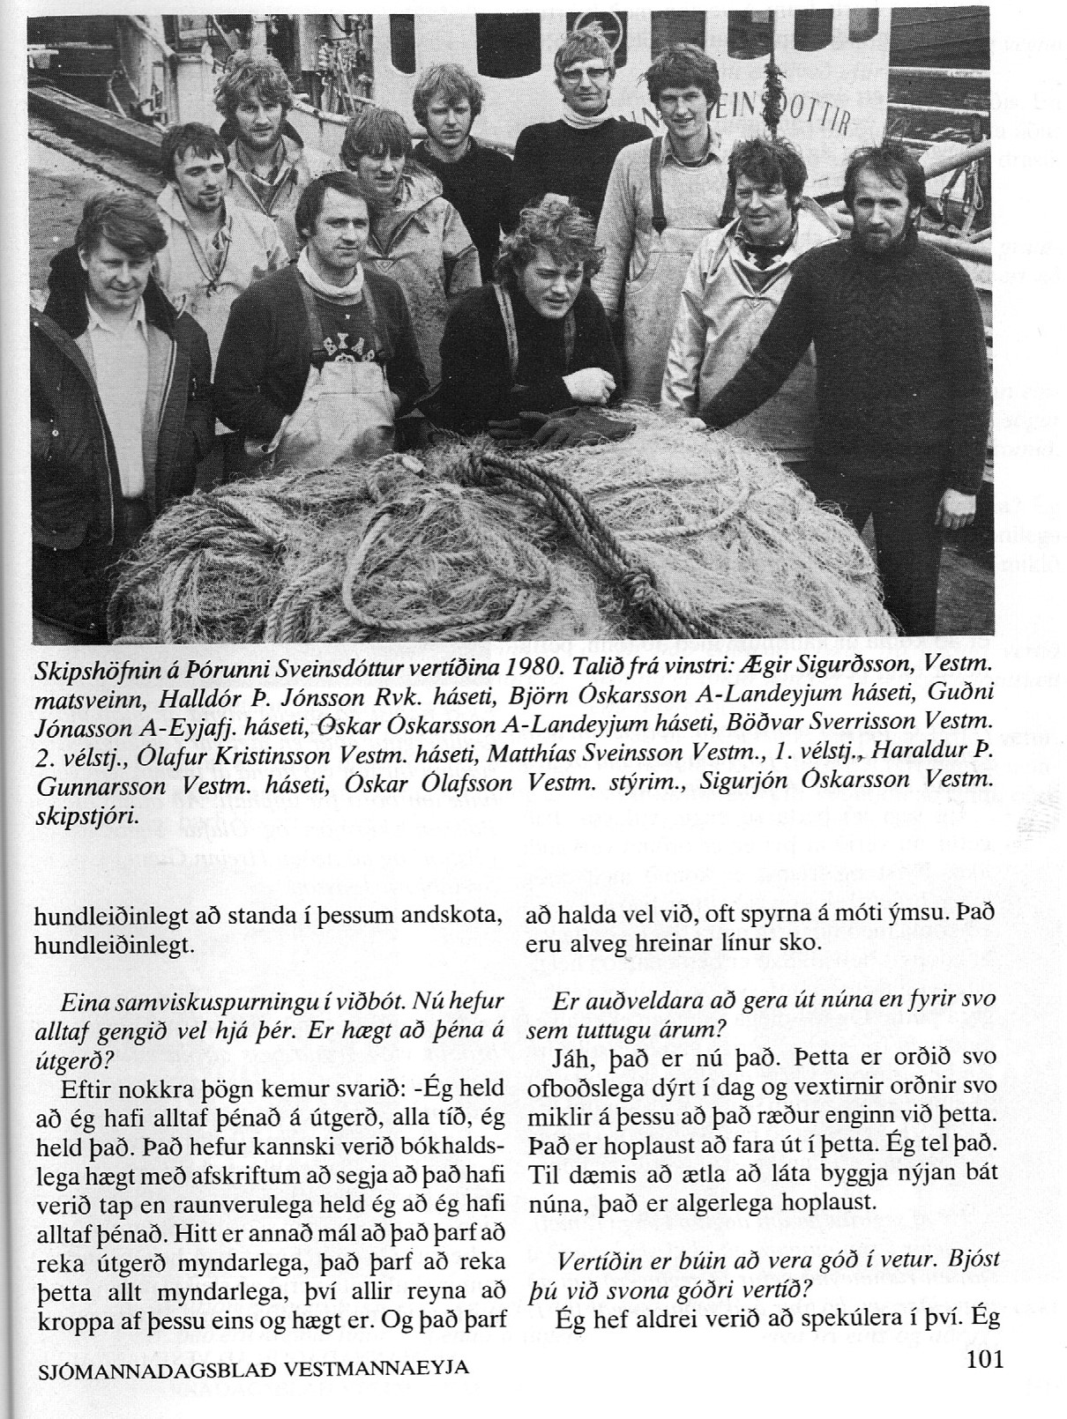

-------------------------------------------------------------3--------------------------------------

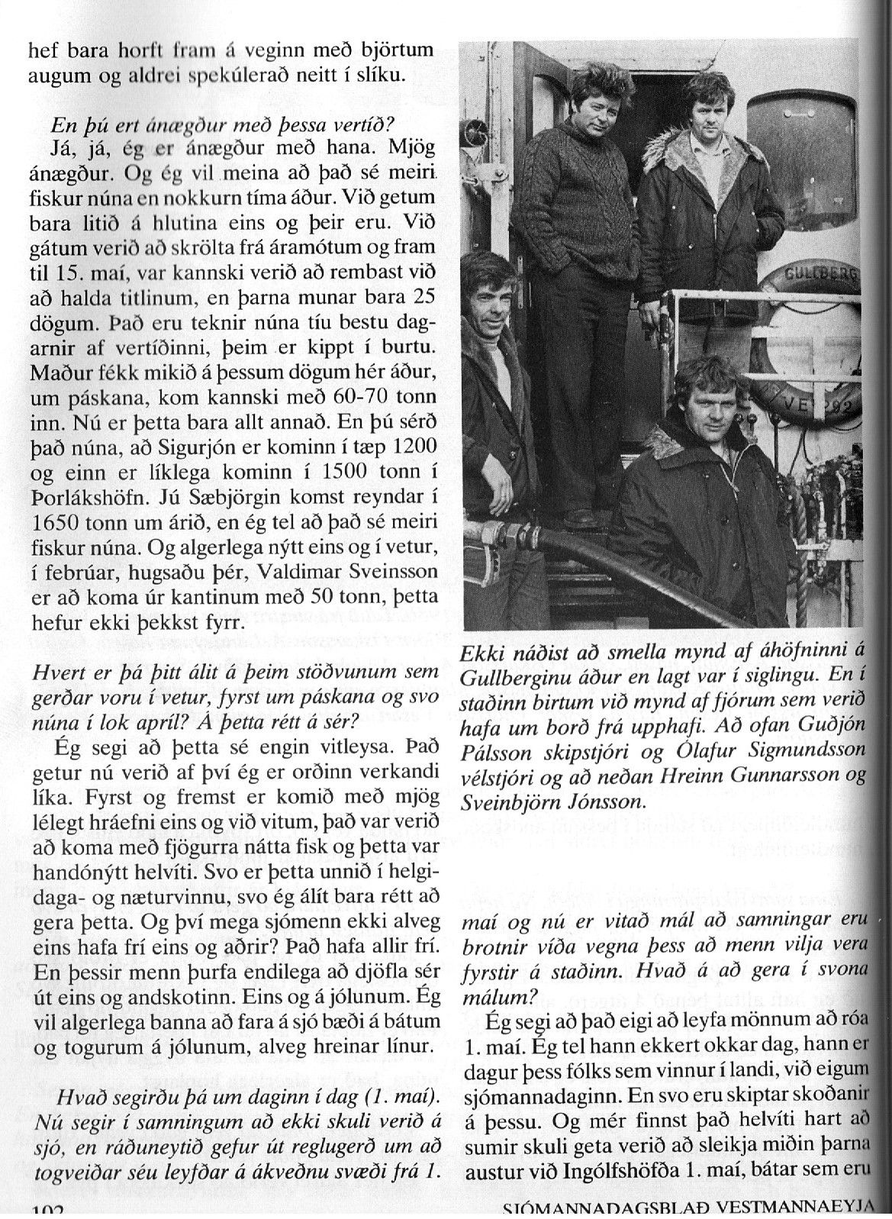

------------------------------------------------------------4-------------------------------------------
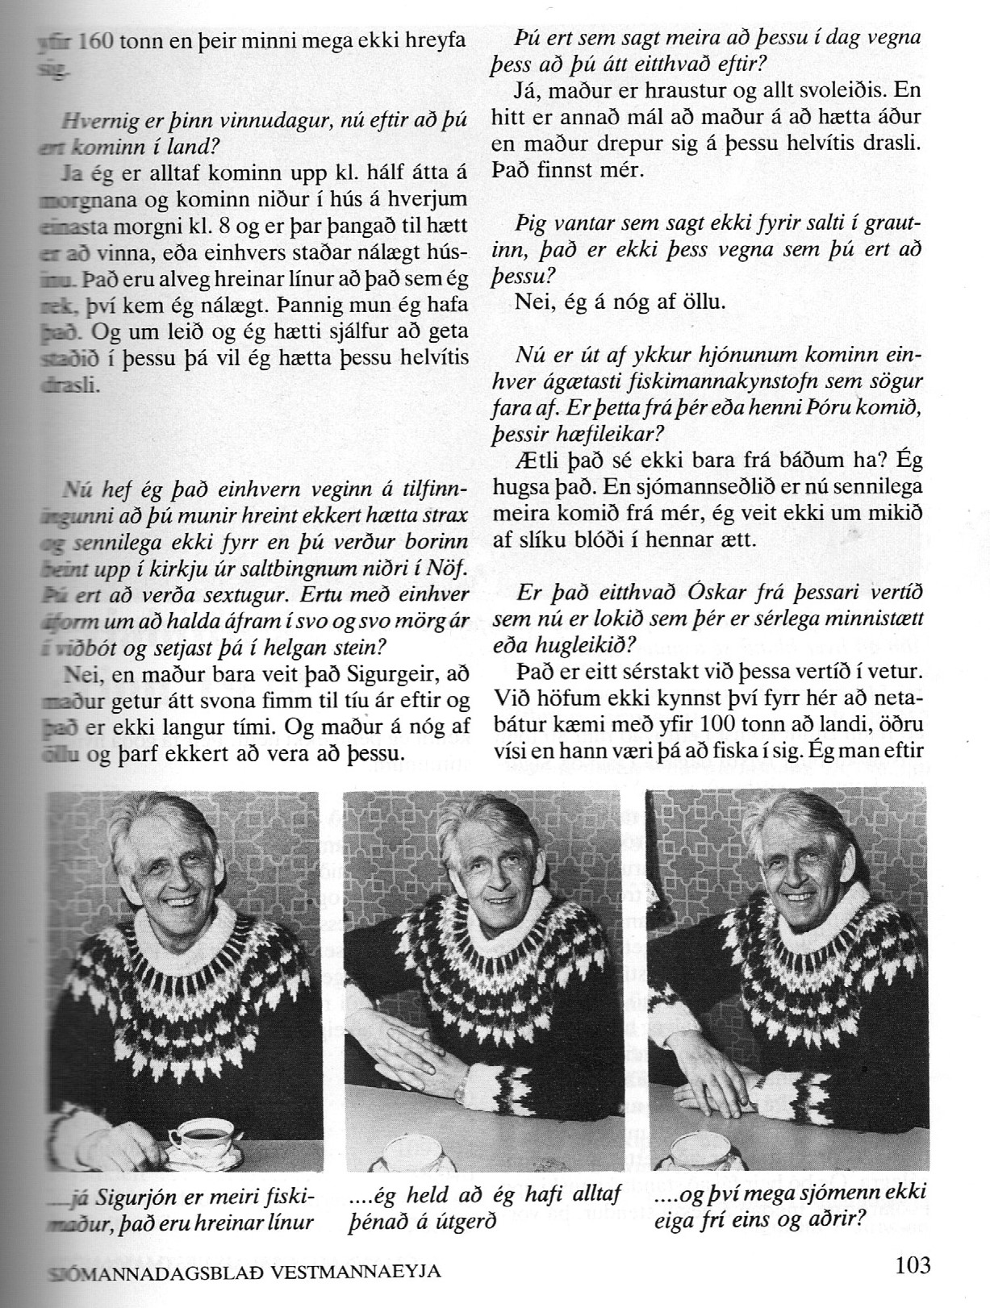

--------------------------------------------------------5-------------------------------------------------------

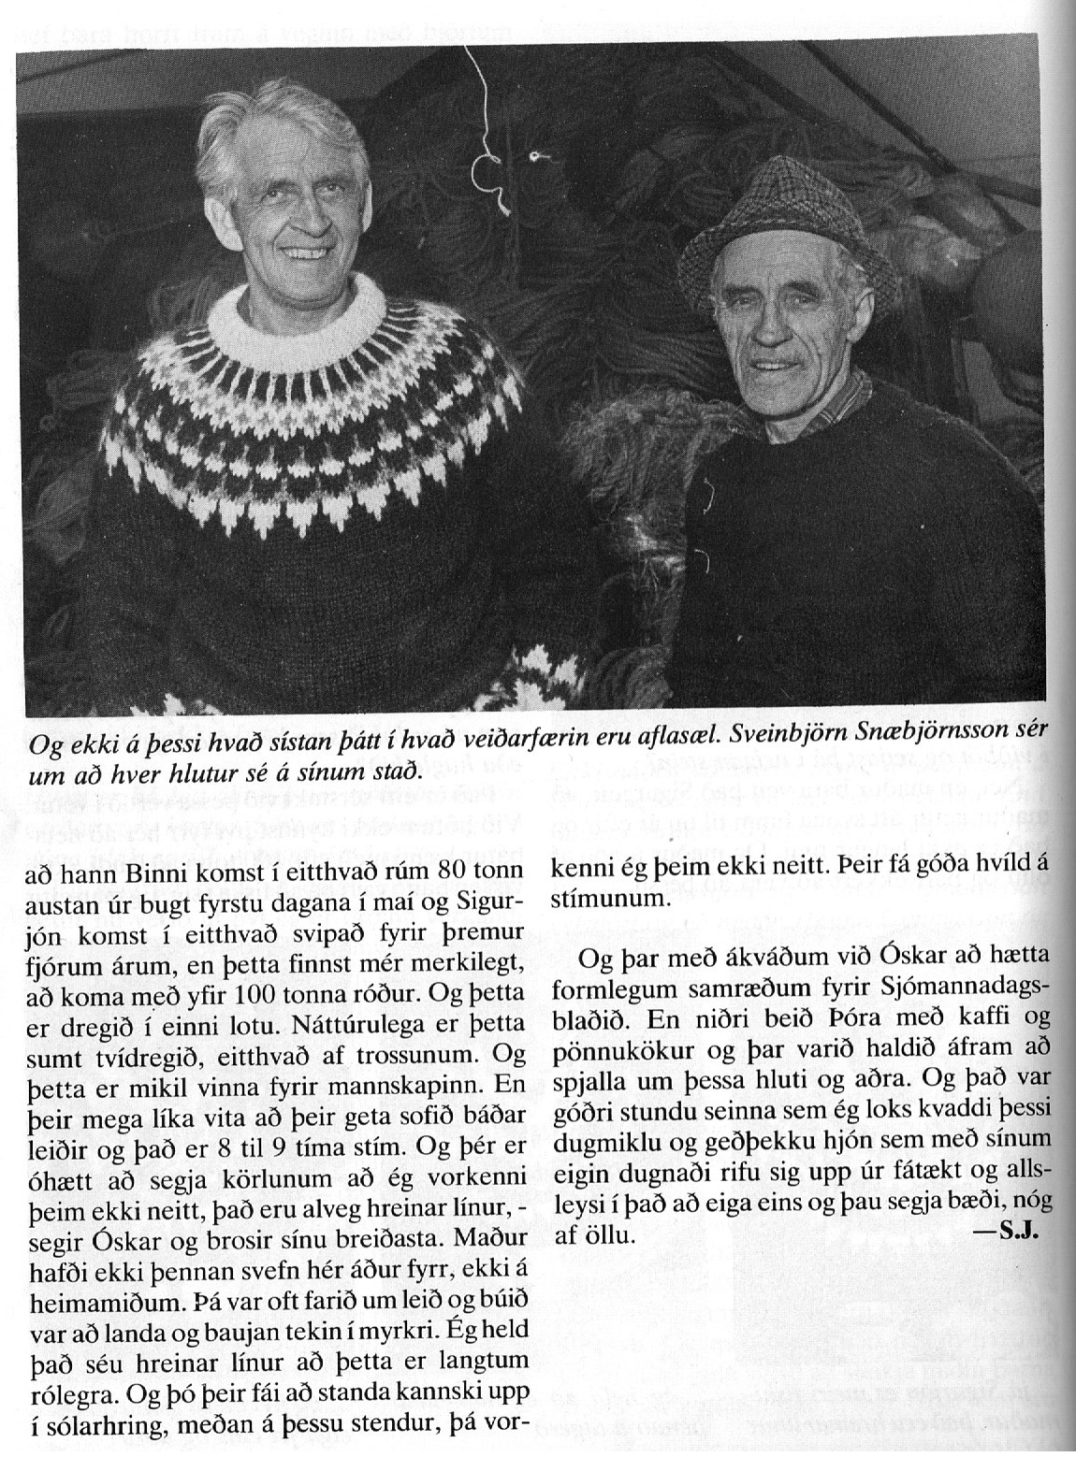

------------------------------------------------------6------------------------------------------------

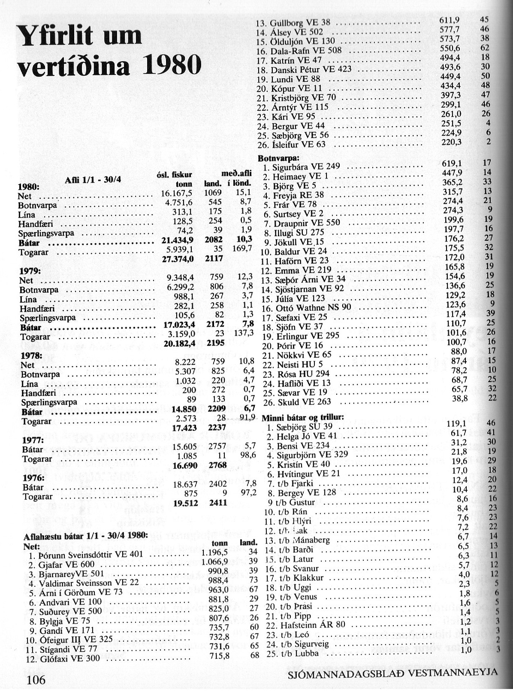

Tekið uppúr sjómannadagsblaði 1980.

