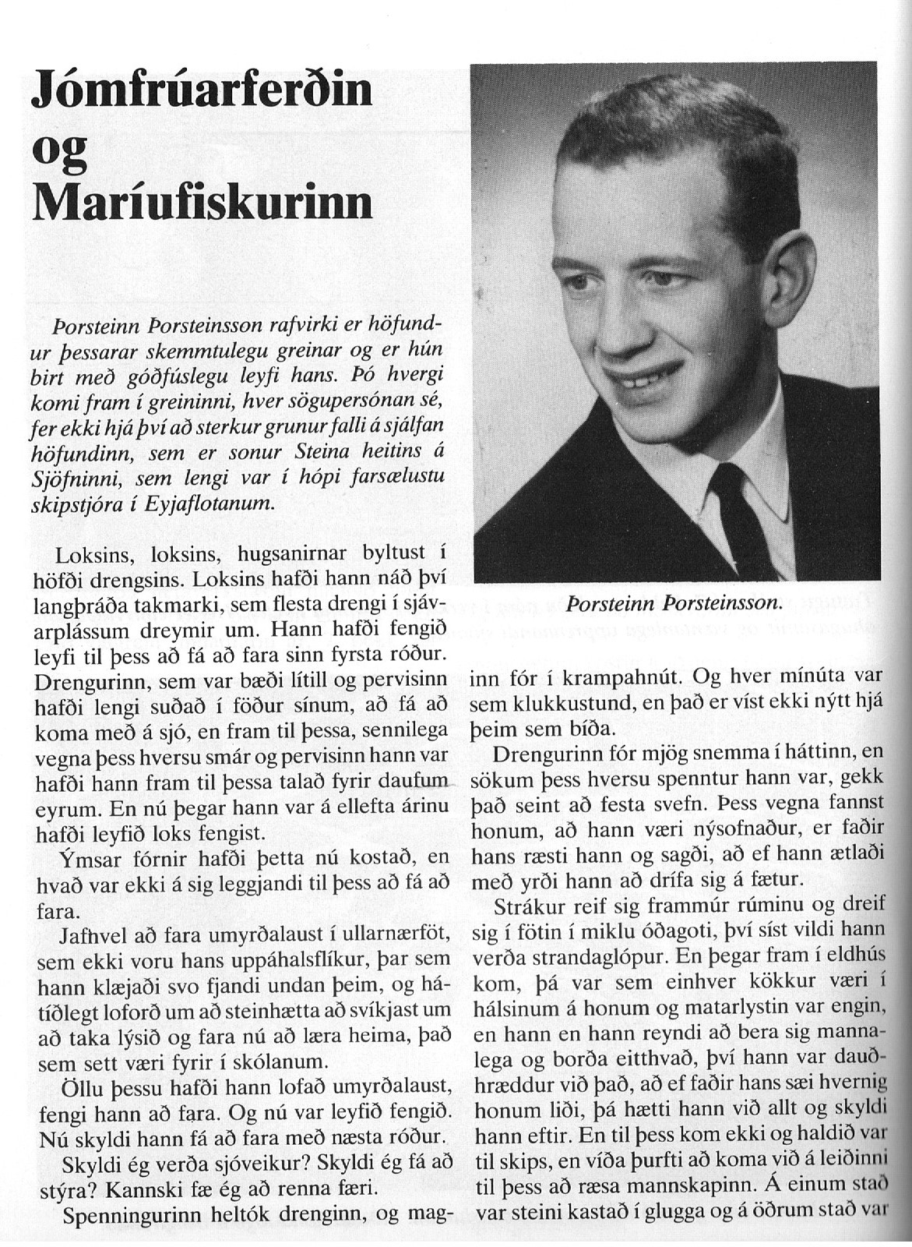

--------------------------------------------------------(1)--------------------------------------------

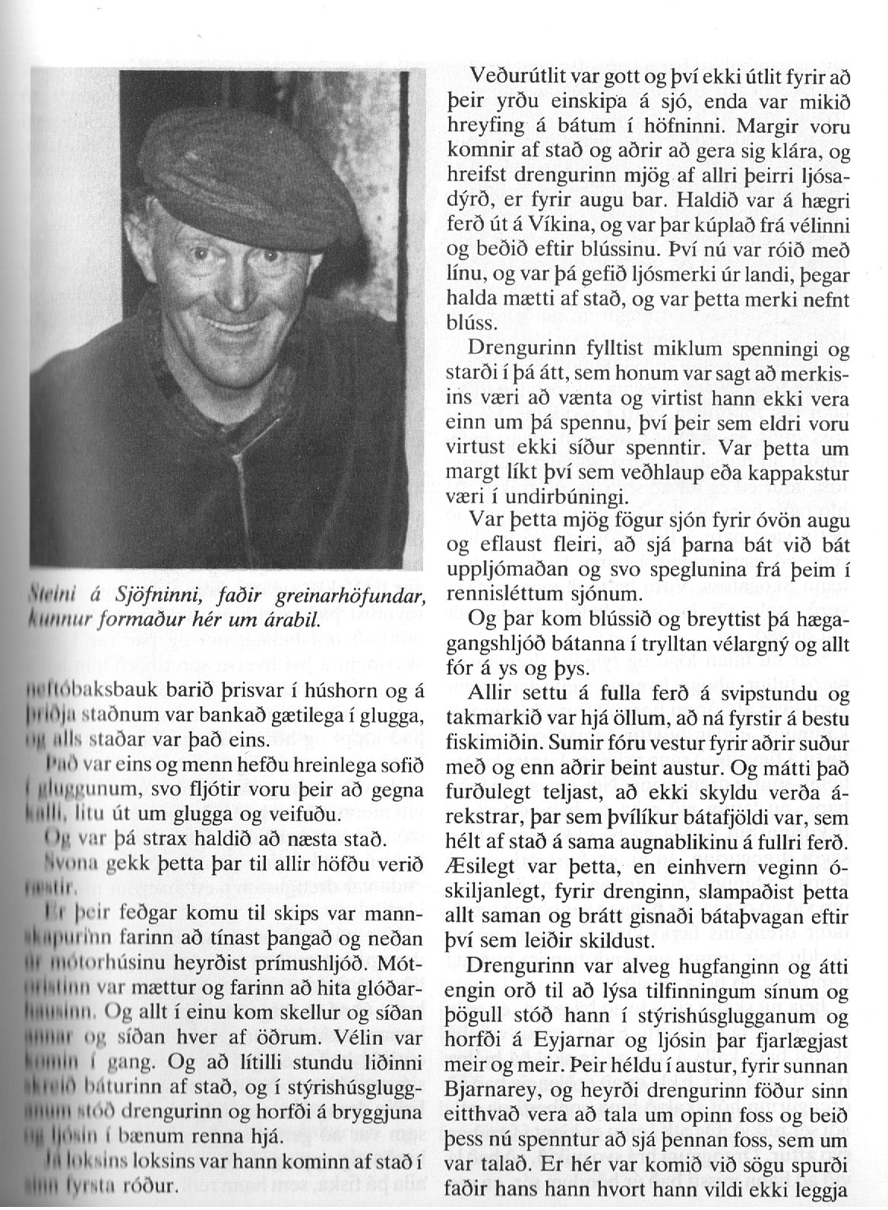

----------------------------------------------------(2)-------------------------------------

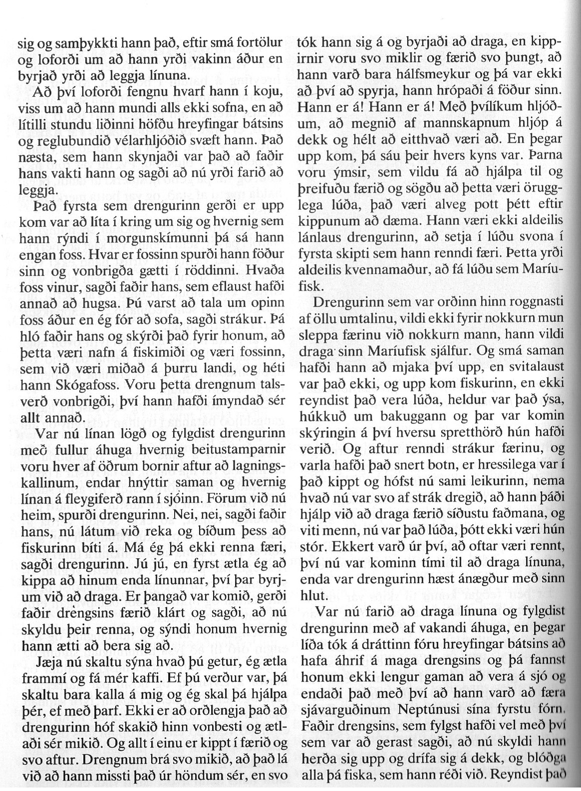

----------------------------------------------(3)-----------------------------------------------

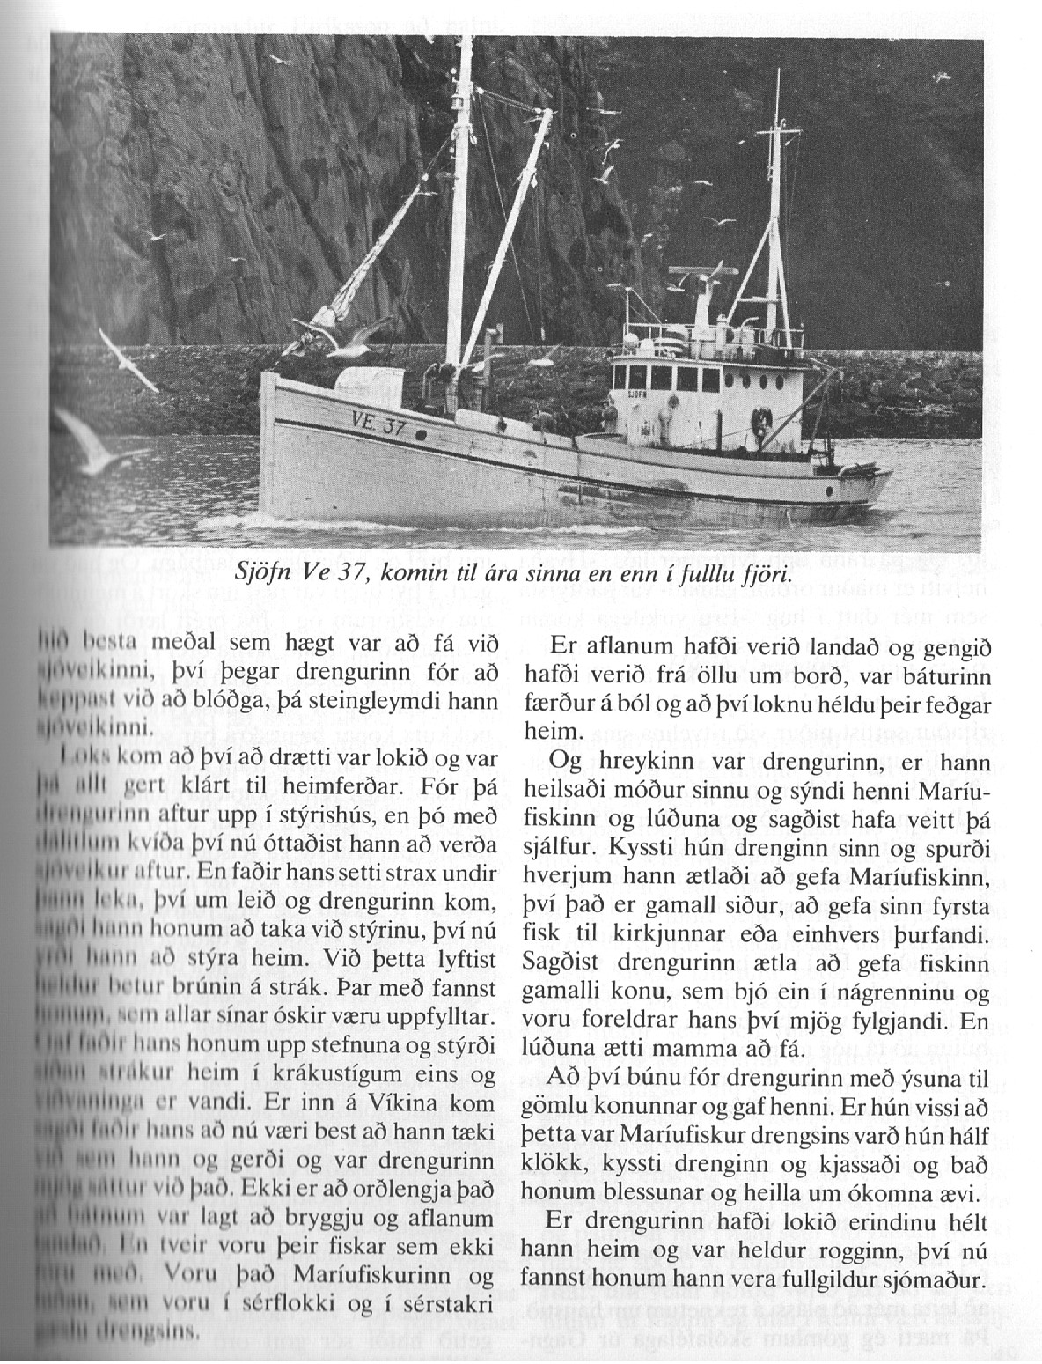

Tekið uppúr sjómannadagsblaði 1980.

