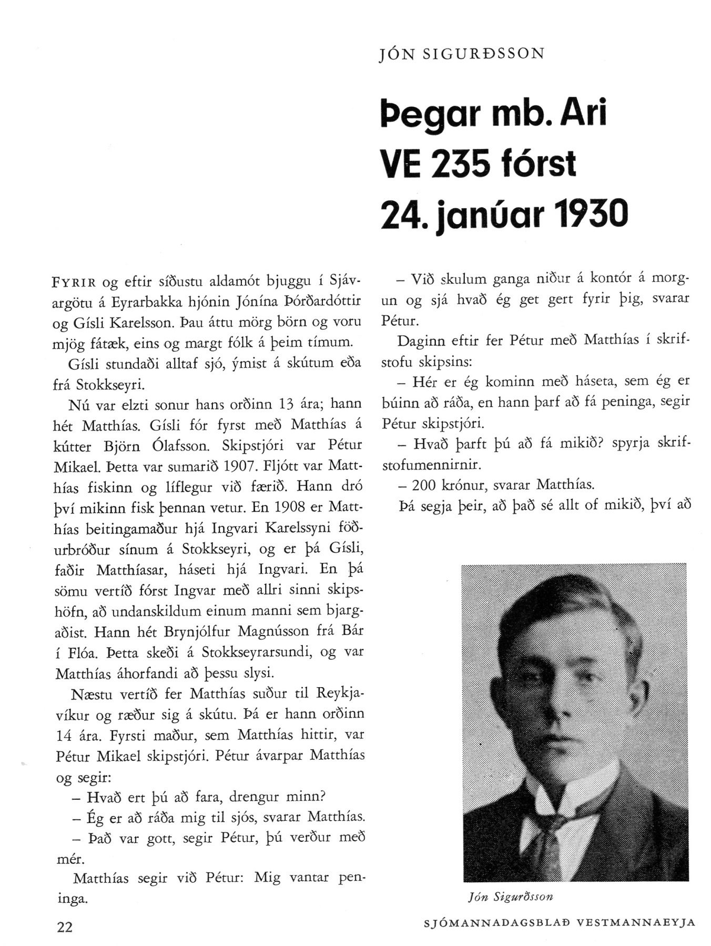

--------------------------------------------------------(1)--------------------------------------------

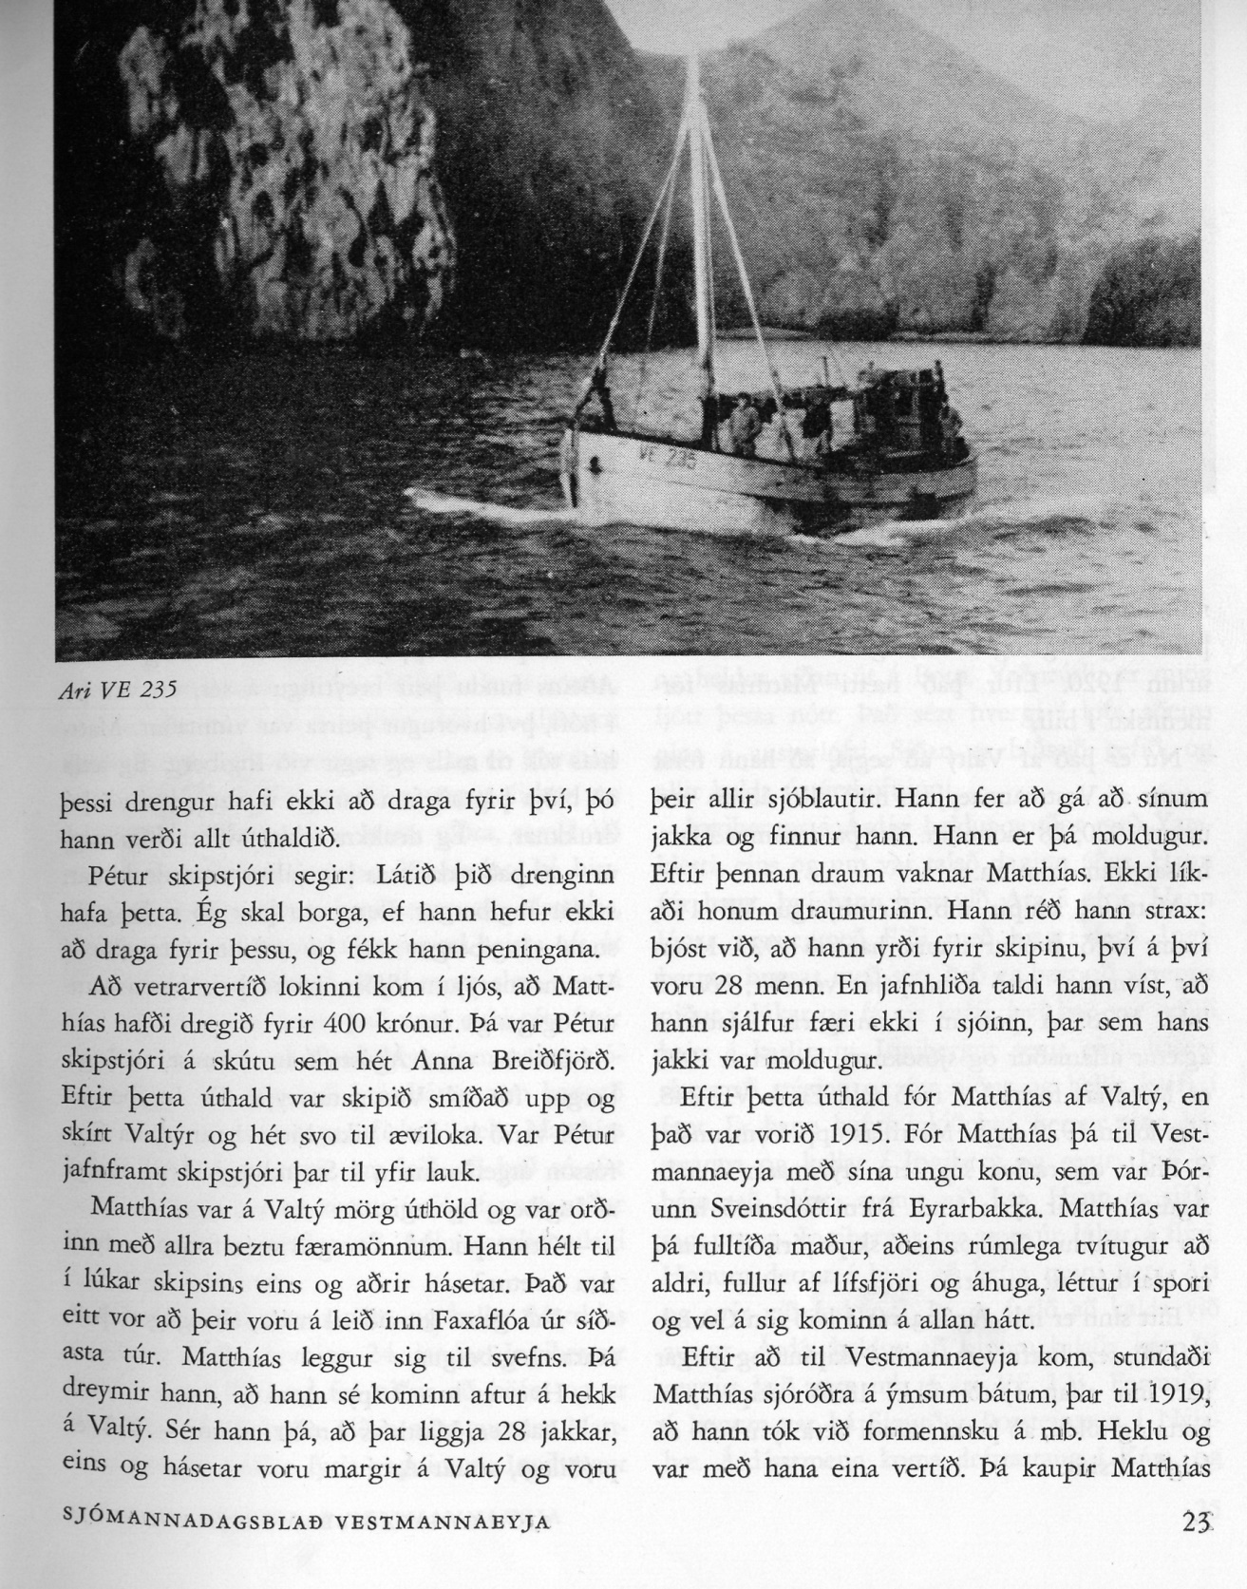
----------------------------------------------------------------(2)---------------------------------------------

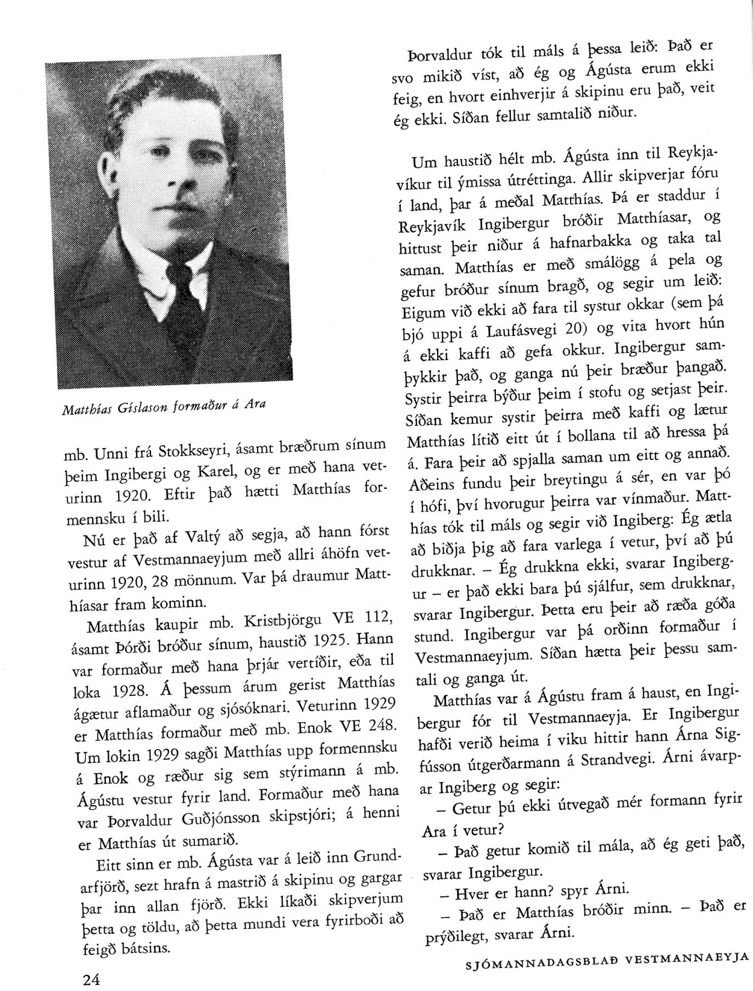
--------------------------------------------------------(3)----------------------------------------------------

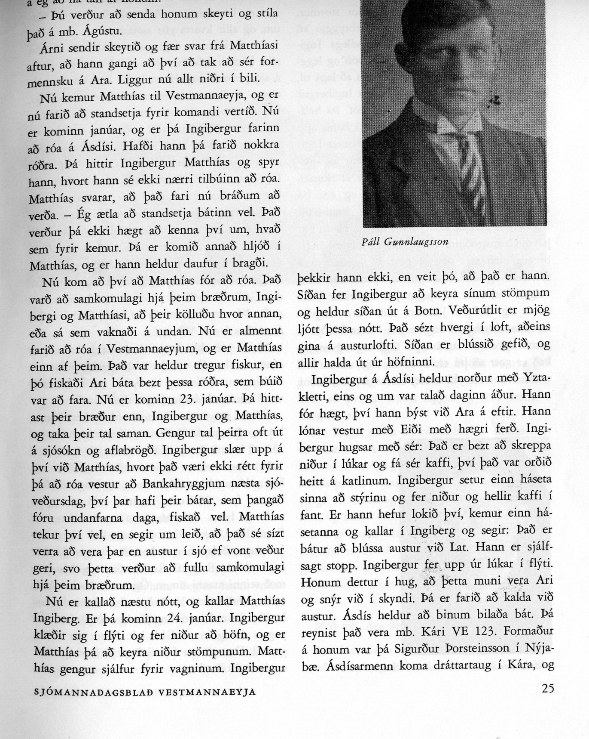
---------------------------------------------------------(4)--------------------------------------------

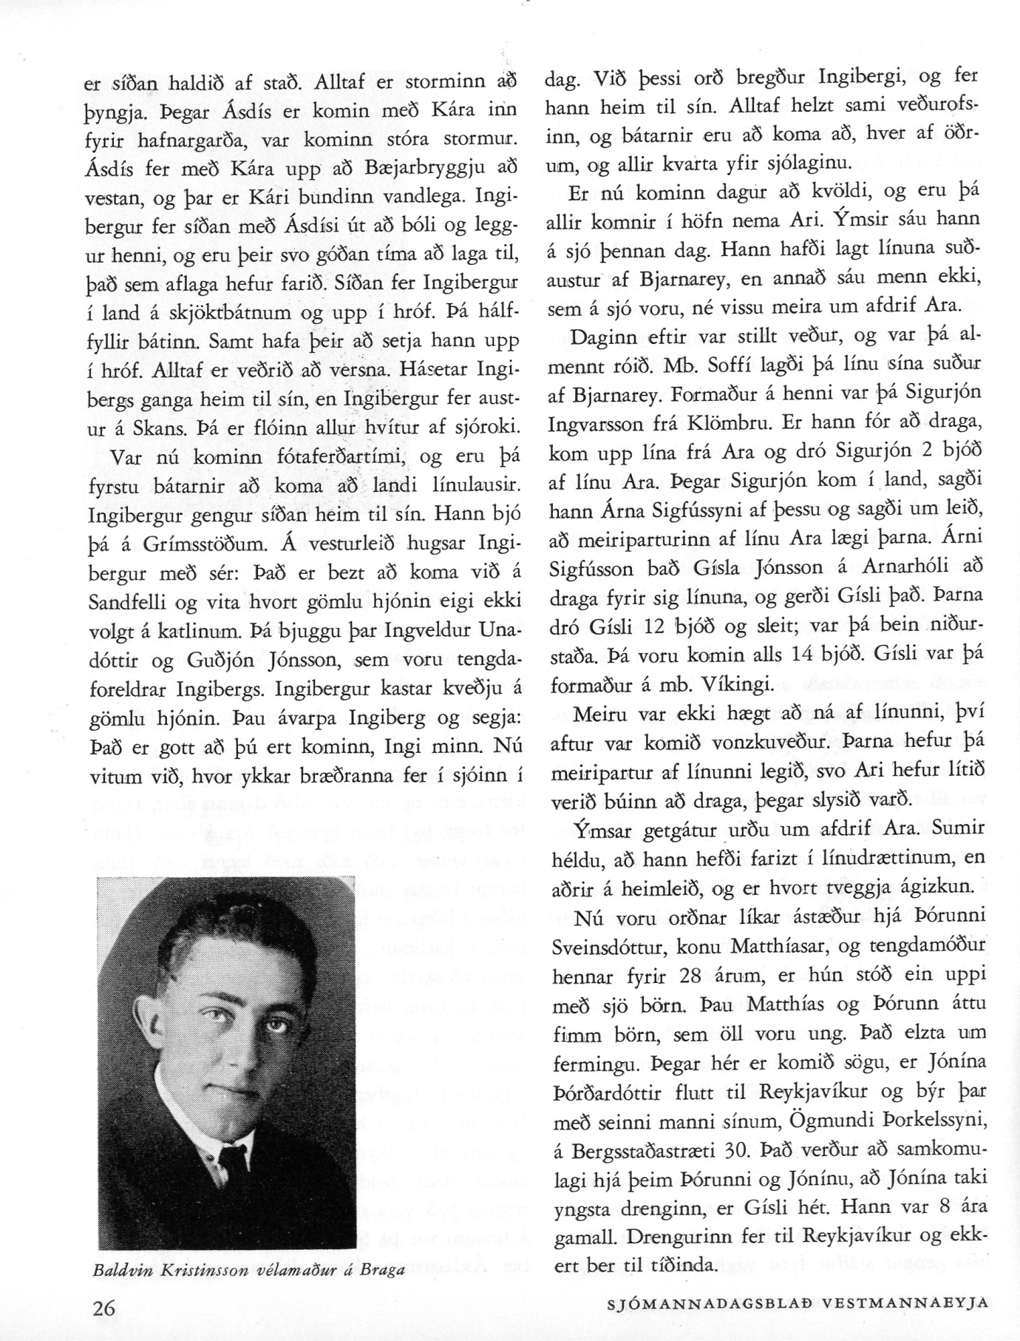

-----------------------------------------------------------(5)-----------------------------------------------

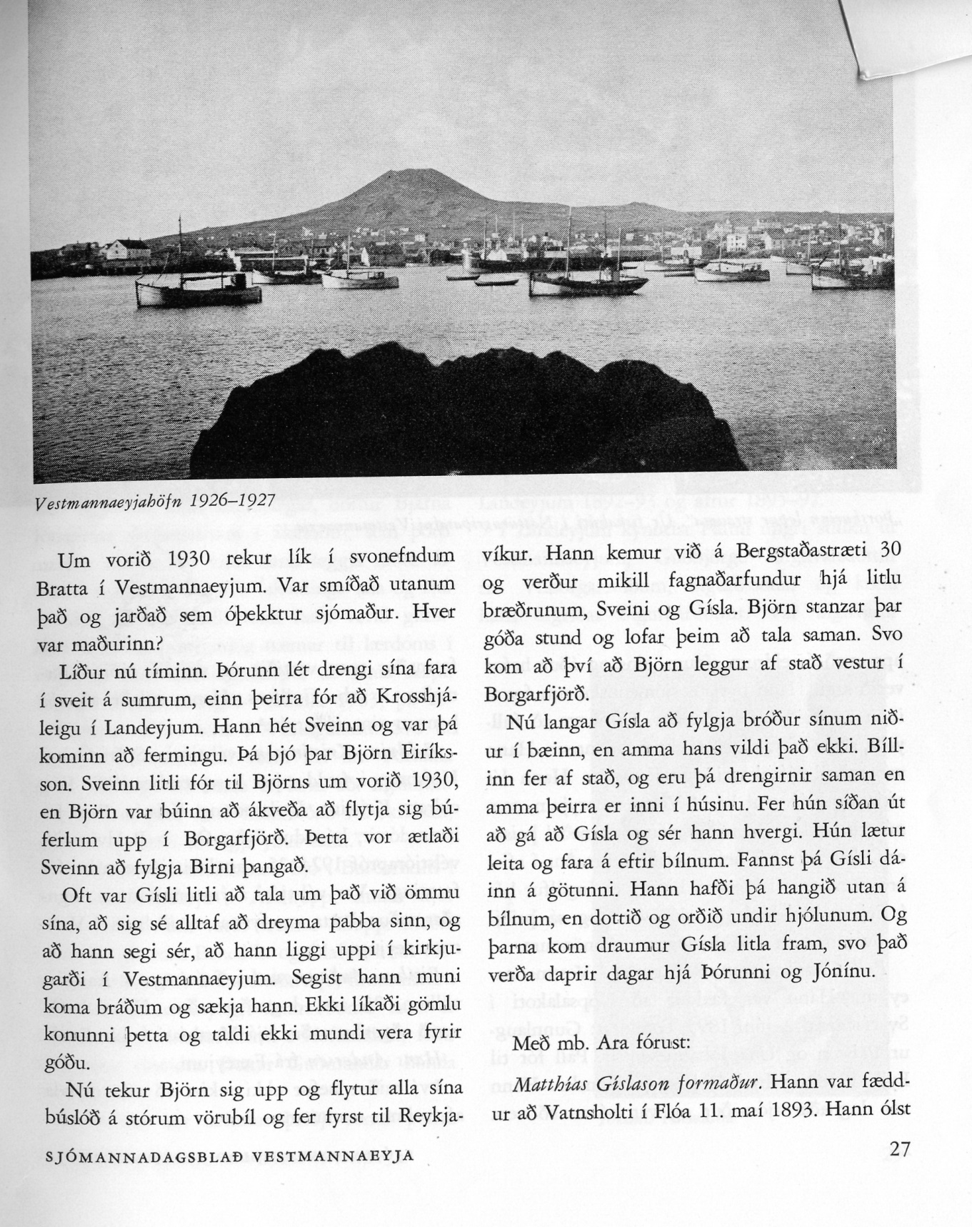

-------------------------------------------------------(6)-------------------------------------------

