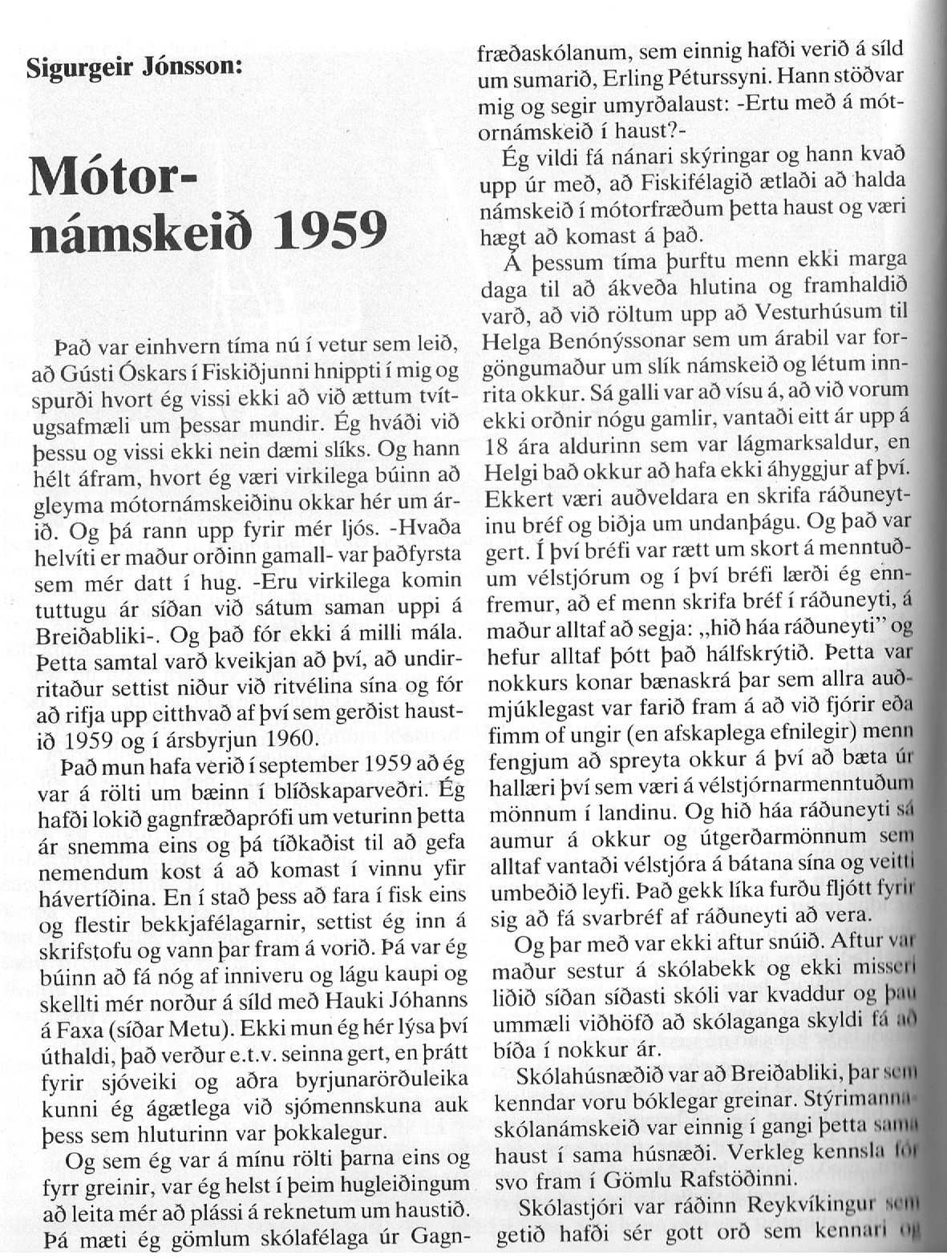

----------------------------------------(1)--------------------------------------------------

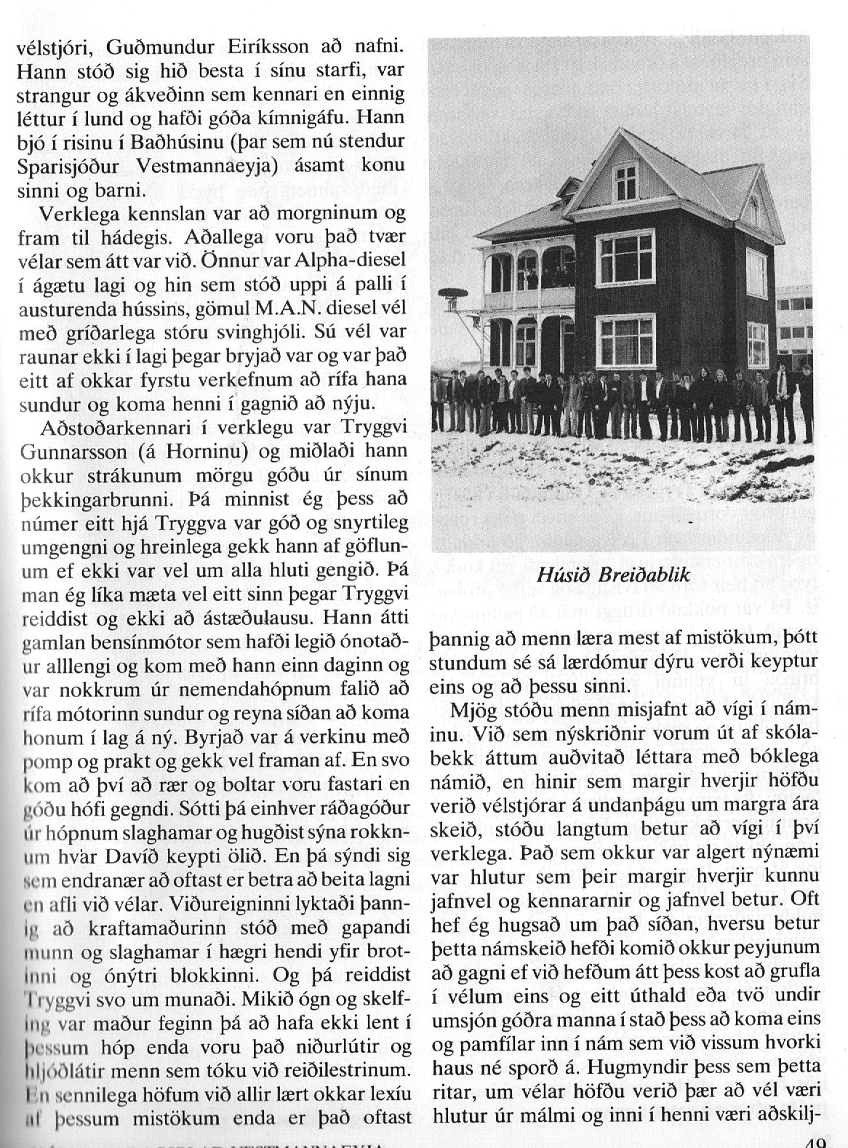

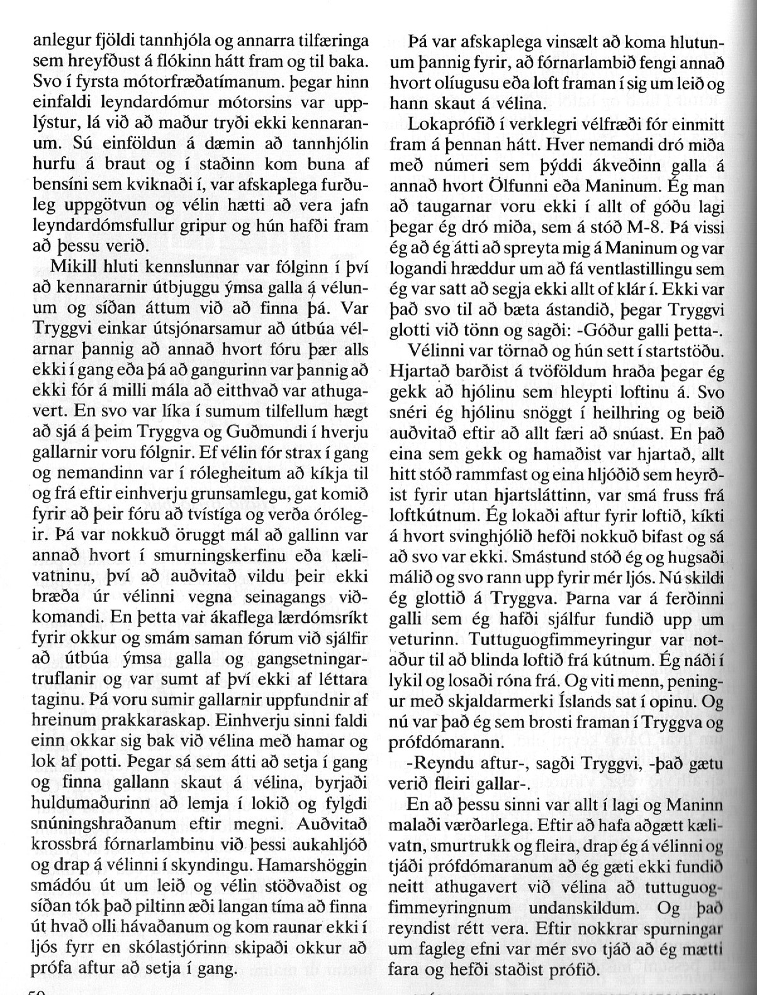

--------------------------------------------------------------(2)-------------------------------------------------

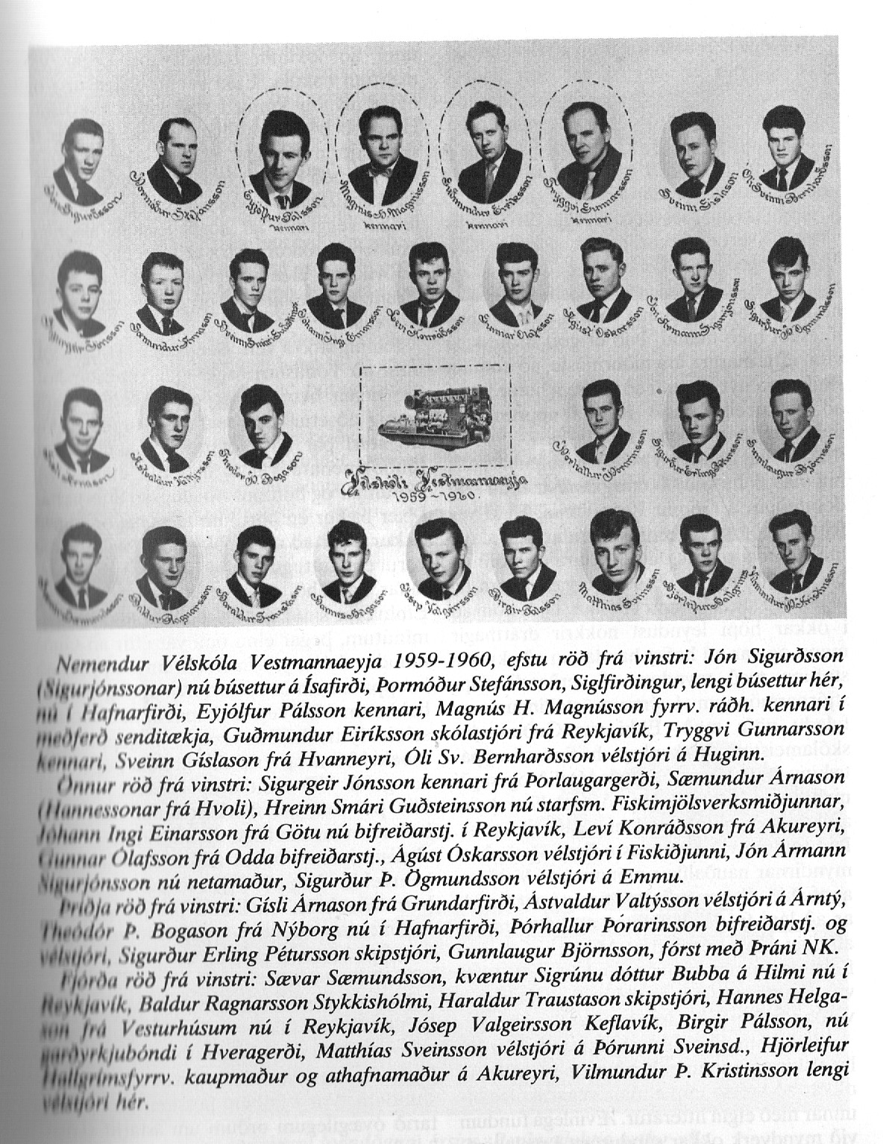

----------------------------------------------------------(3-------------------------------------------------------

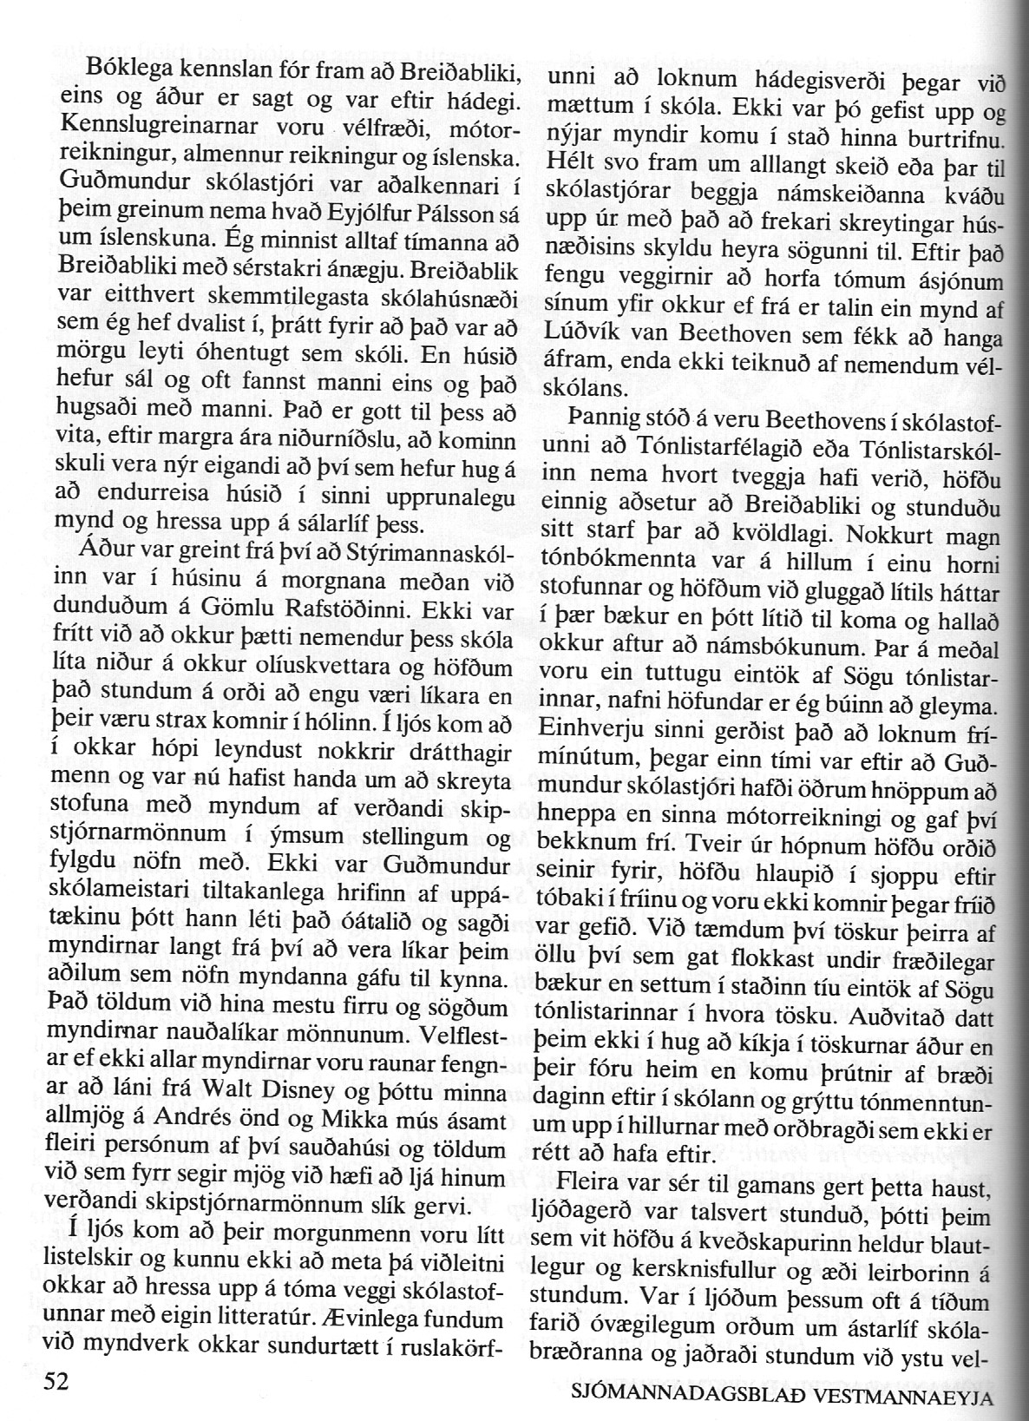

----------------------------------------------------------------(4)-----------------------------------------------

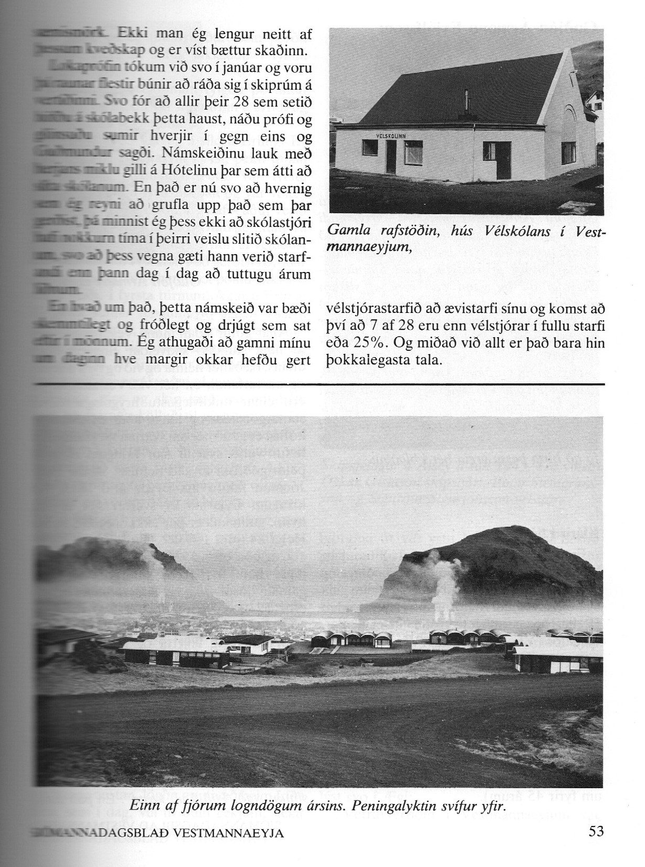

Tekið uppúr sjómannadagsblaði 1980.

