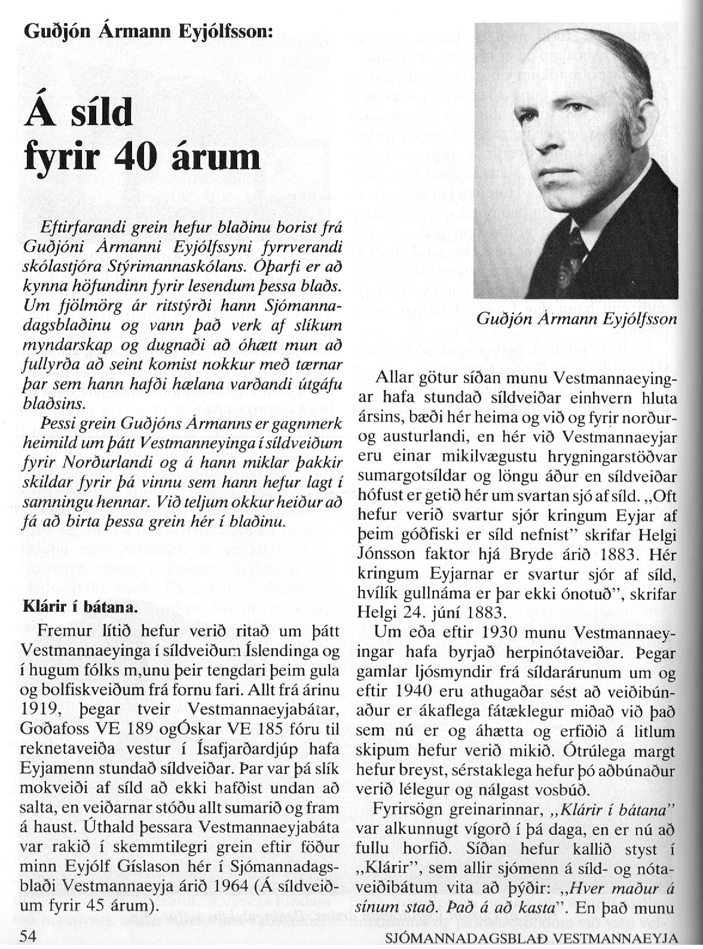

--------------------------------------------------------1--------------------------------------

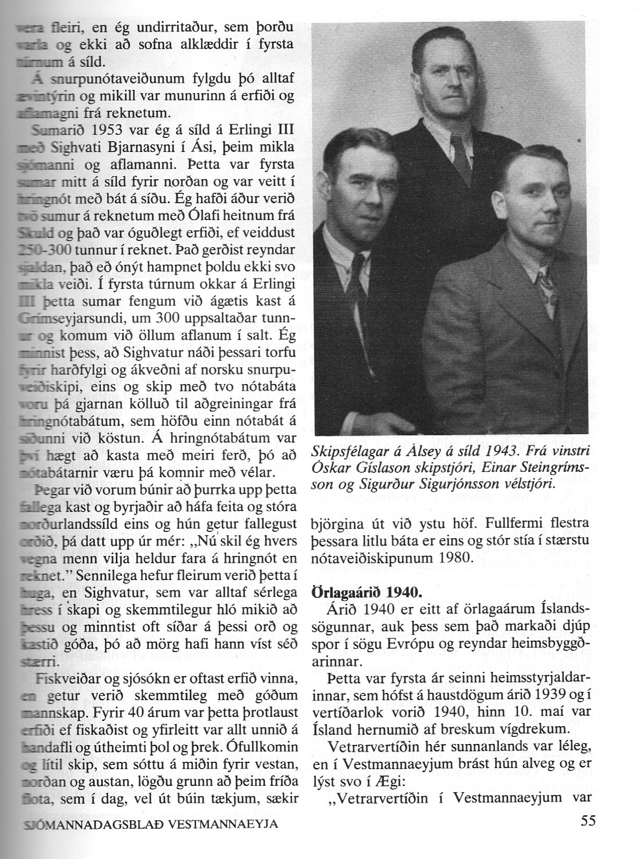

-------------------------------------------------------------2------------------------------------

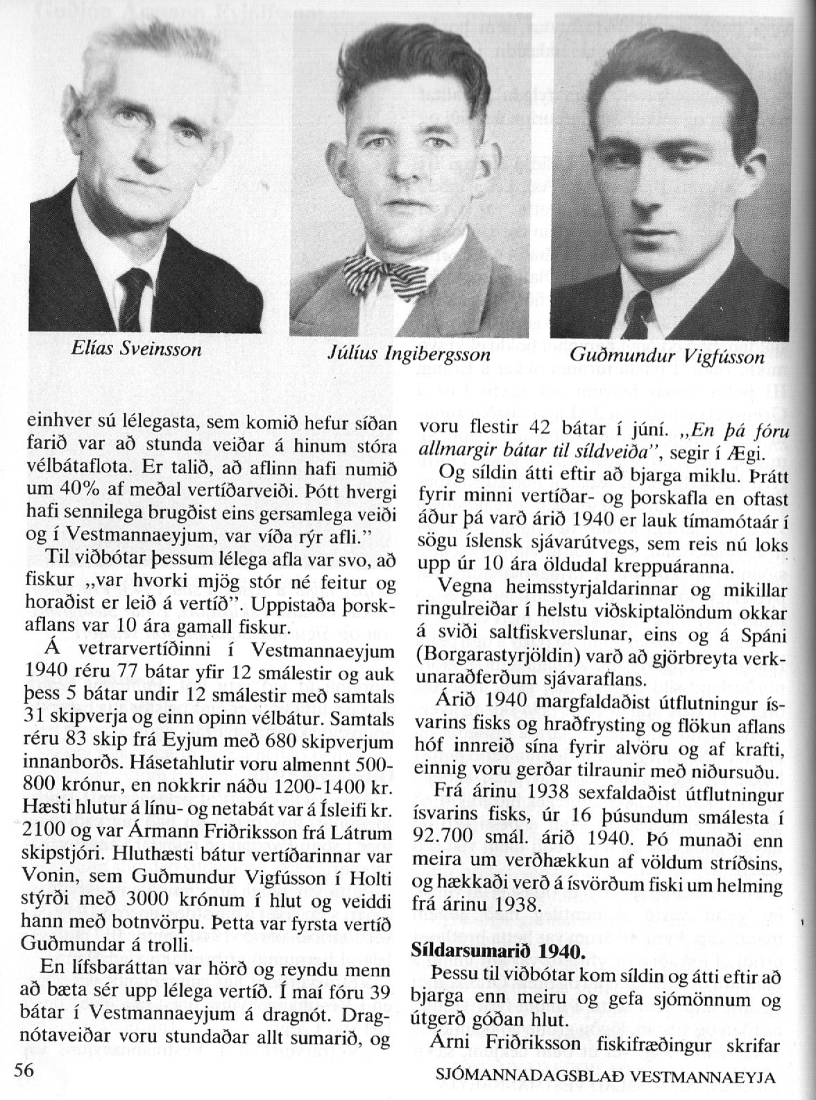

-----------------------------------------------------3---------------------------------------

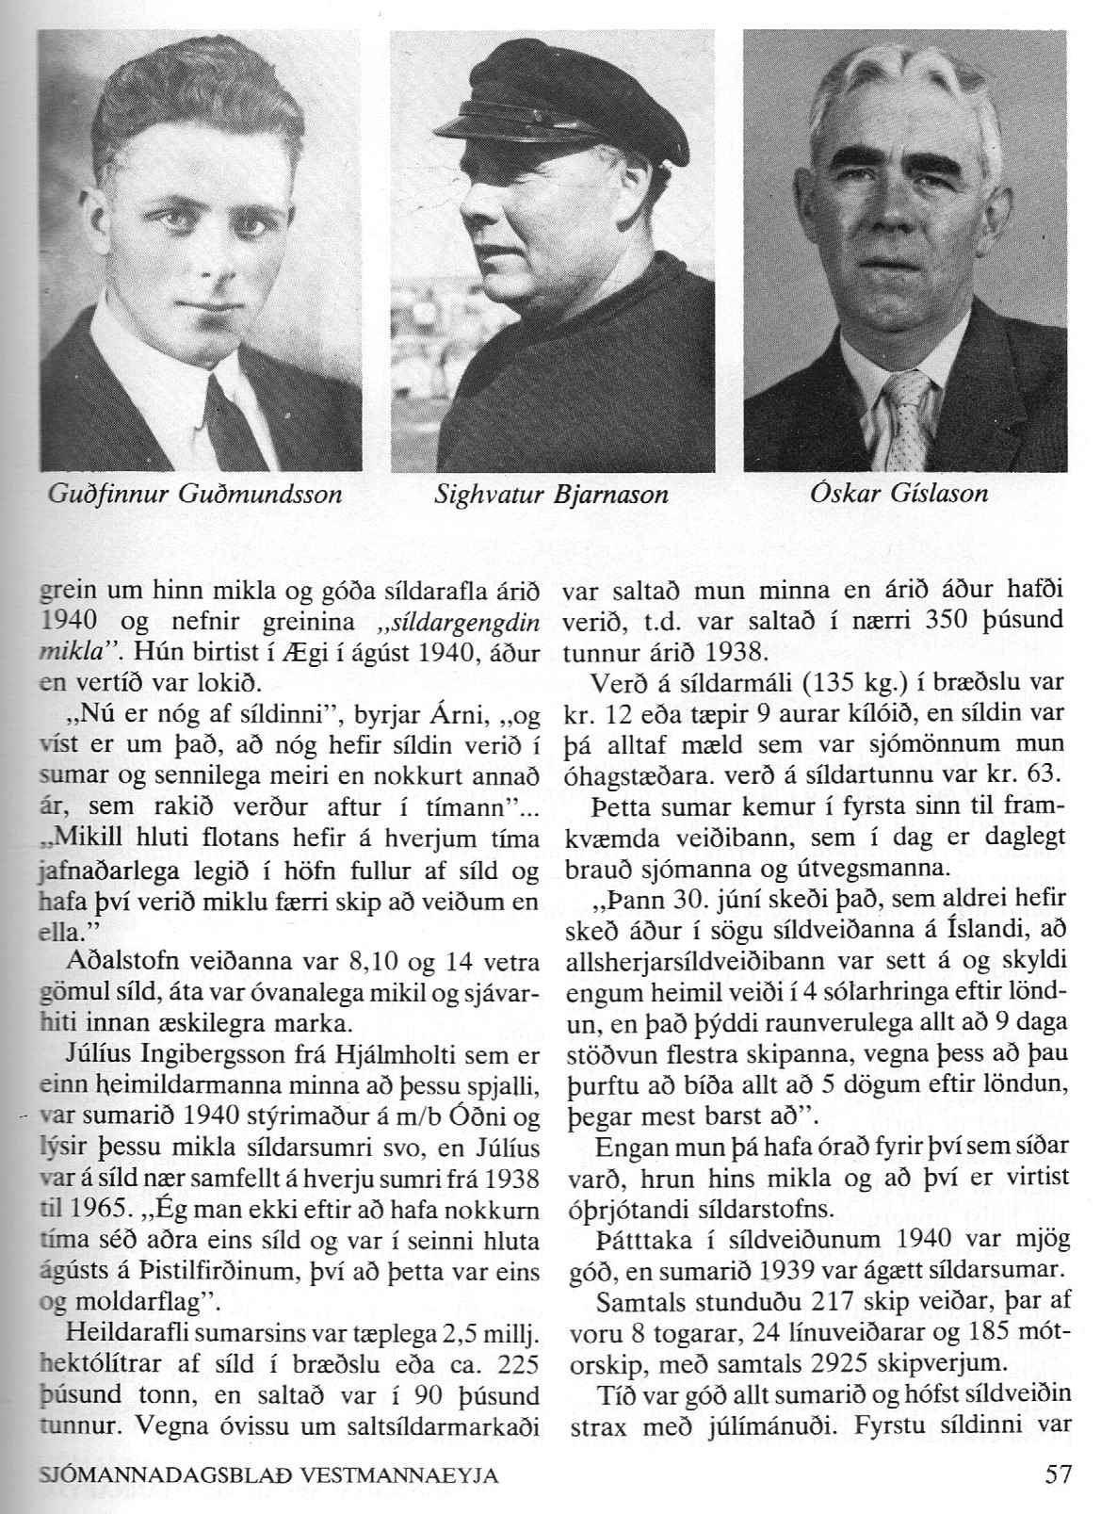

-----------------------------------------------------4-------------------------------------------

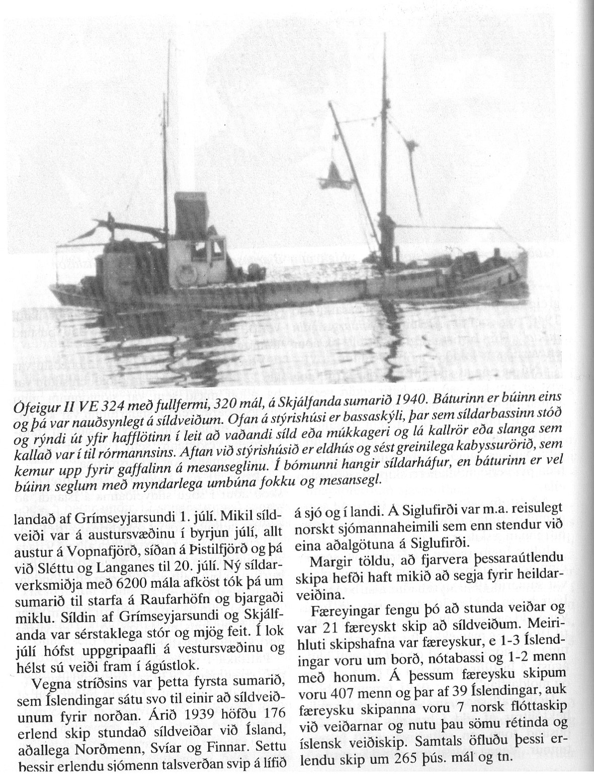

---------------------------------------------5-----------------------------------------------

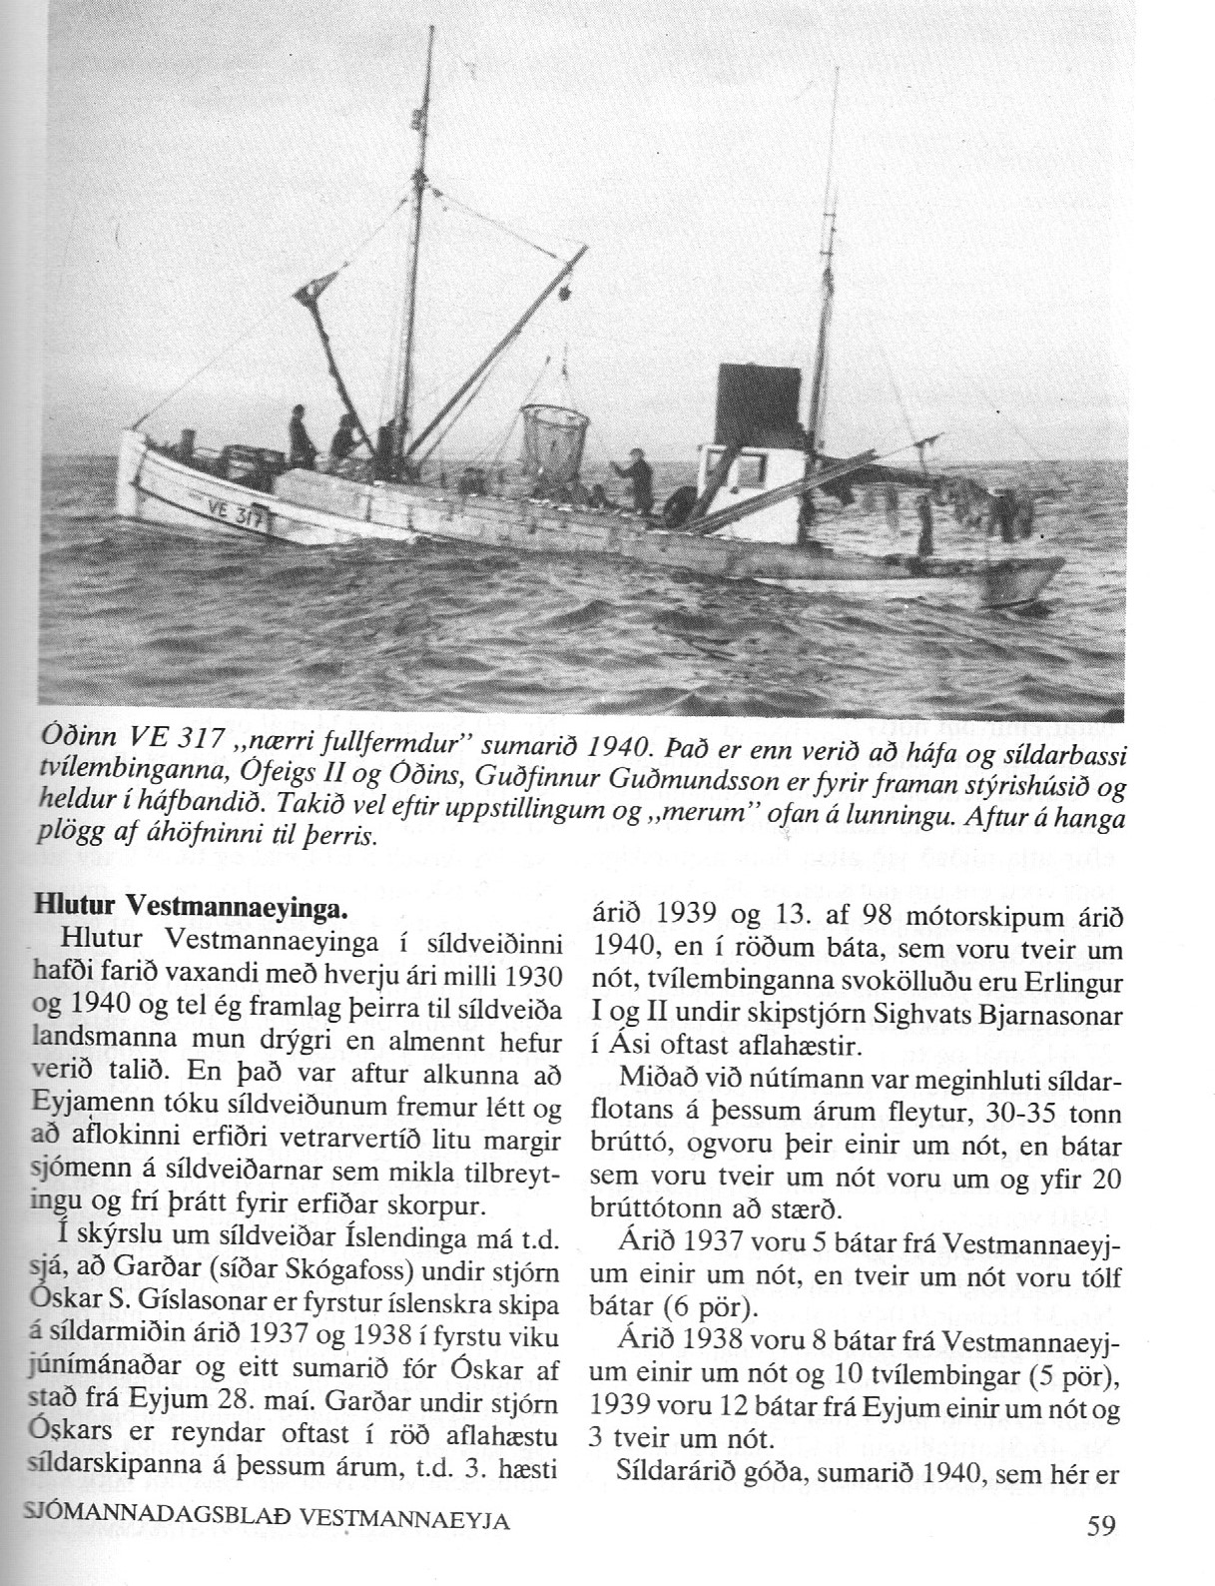

-------------------------------------------------6-------------------------------------------------------

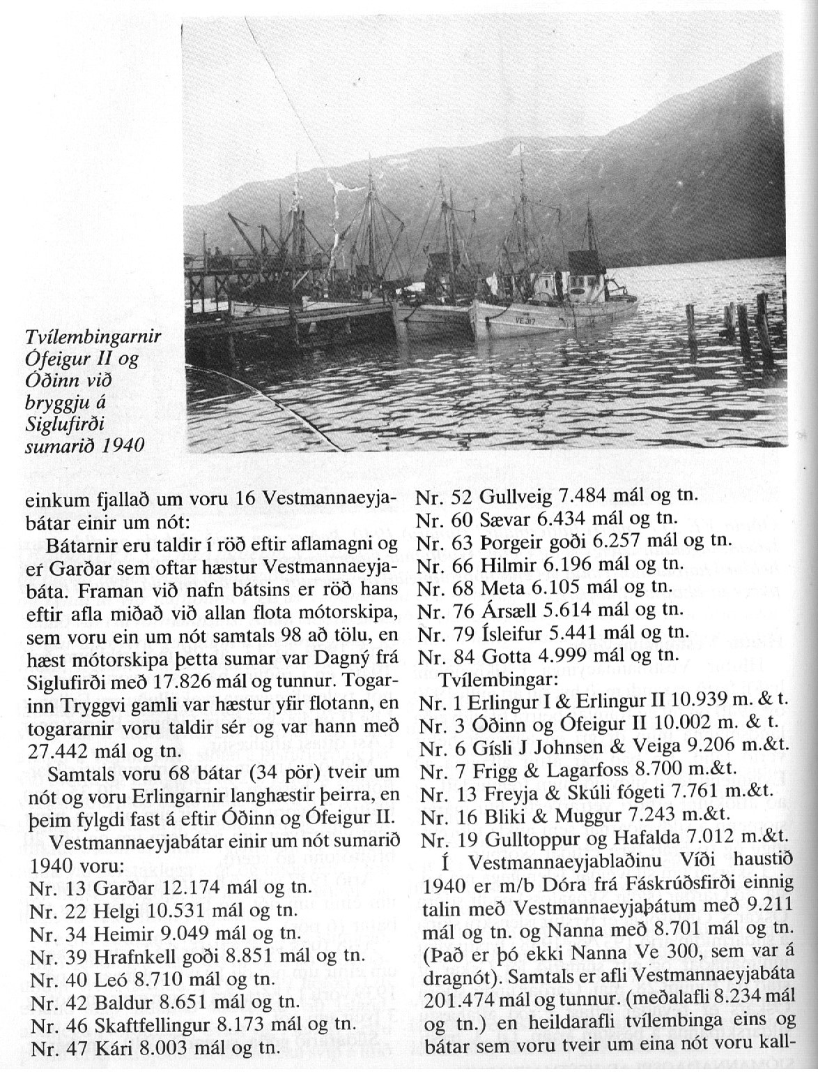

-------------------------------------------7----------------------------------------

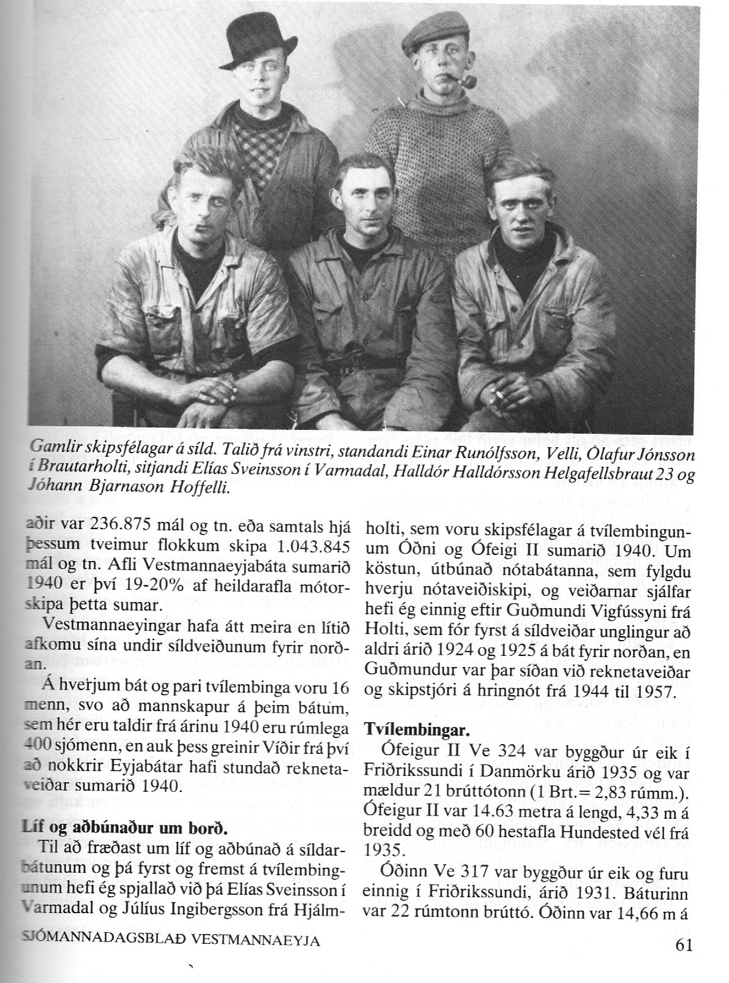

-----------------------------------------------8---------------------------------------

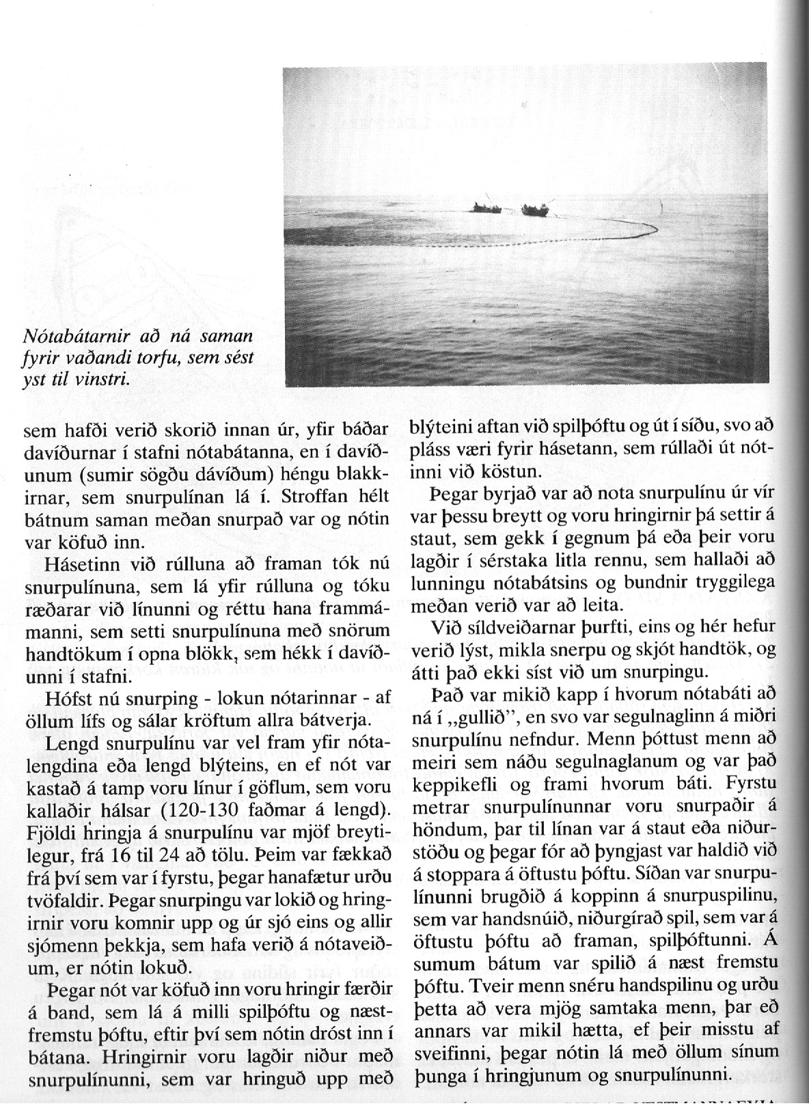

---------------------------------------------9--------------------------------------------

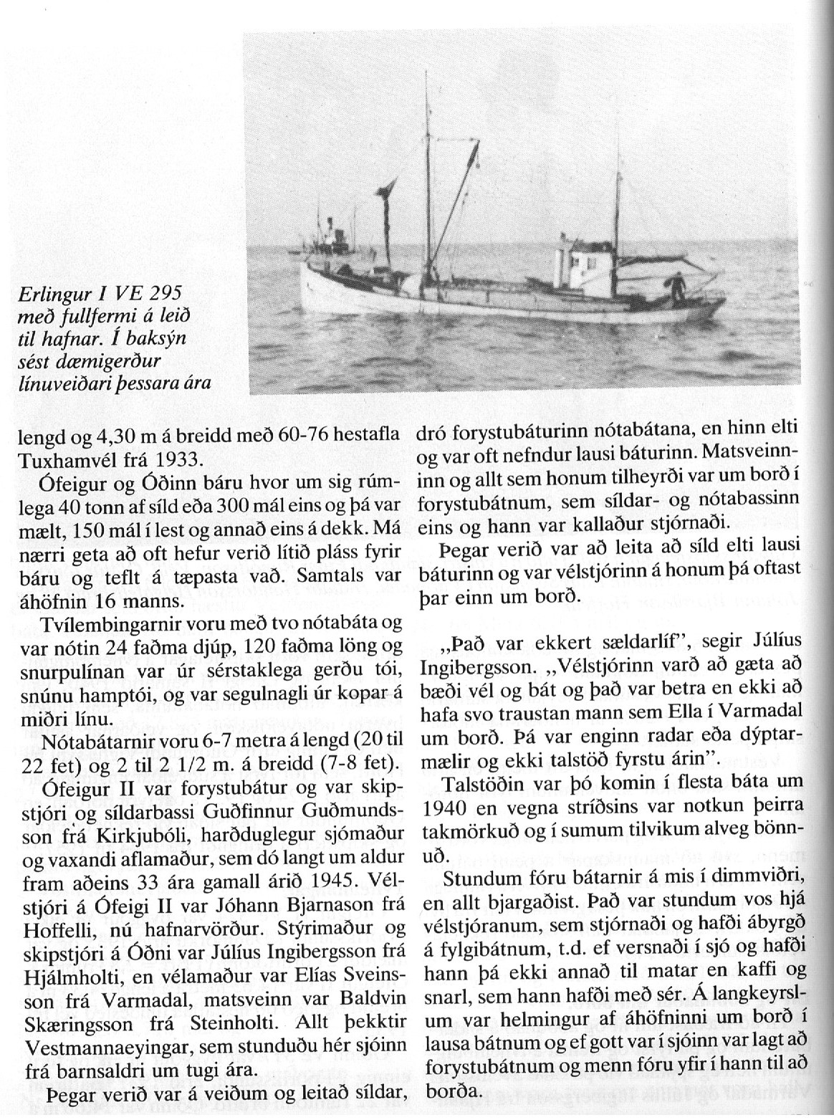

-----------------------------------------------10-------------------------------------

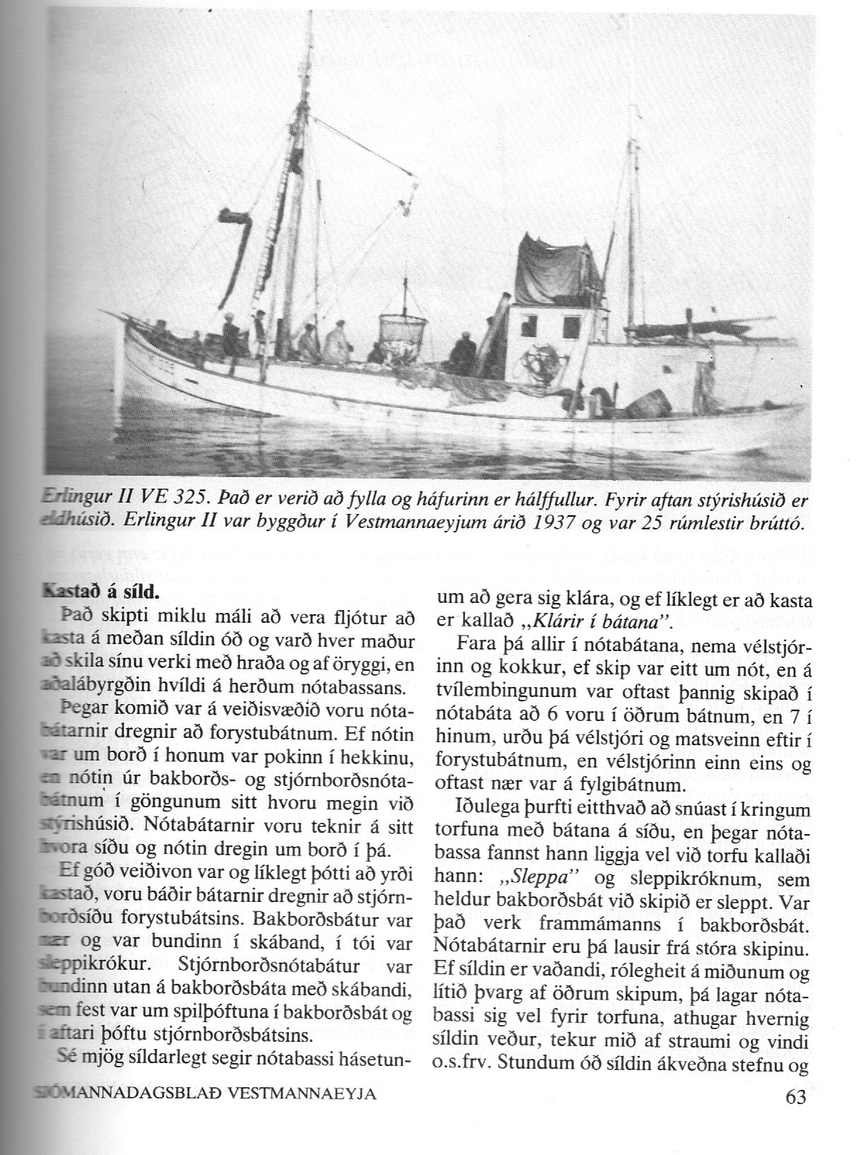

-------------------------------------------11-------------------------------------

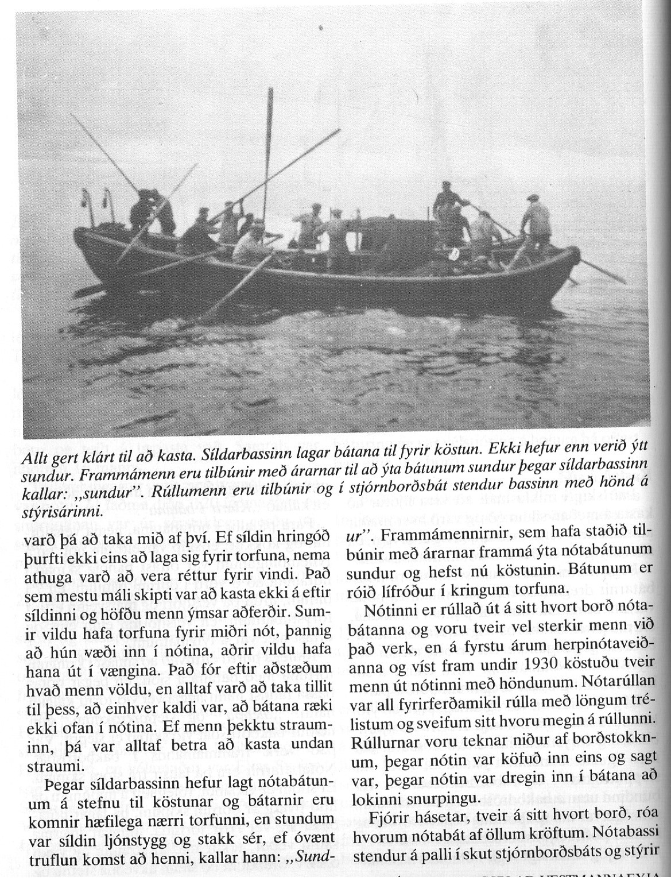

------------------------------------------------12-----------------------------------

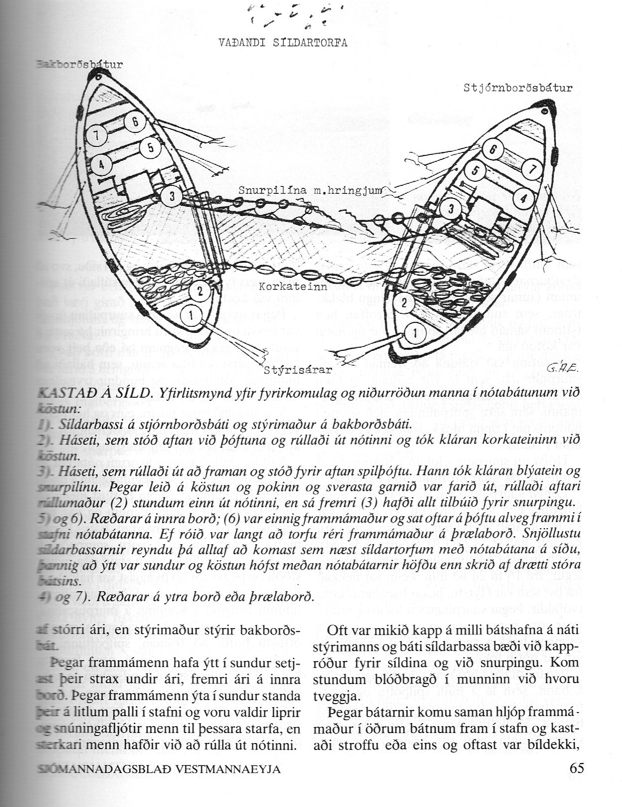

----------------------------------------------------13---------------------------------------------

-------------------------------------------------------14------------------------------------

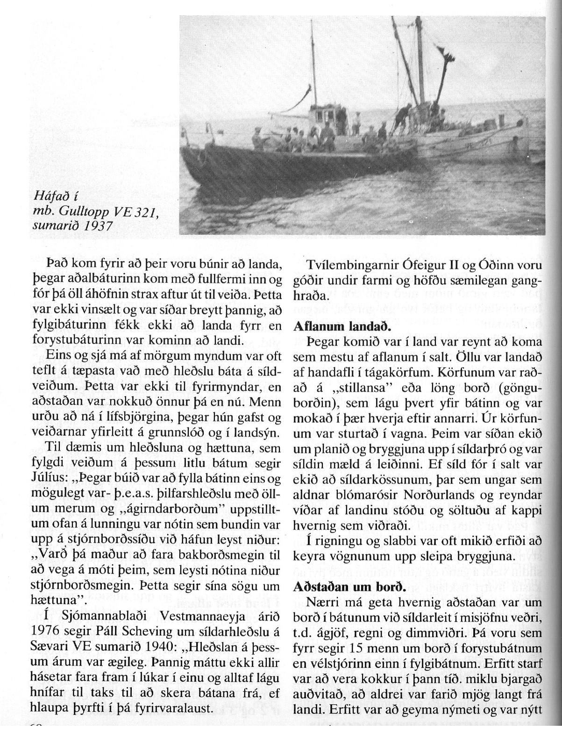

--------------------------------------------15--------------------------------------------

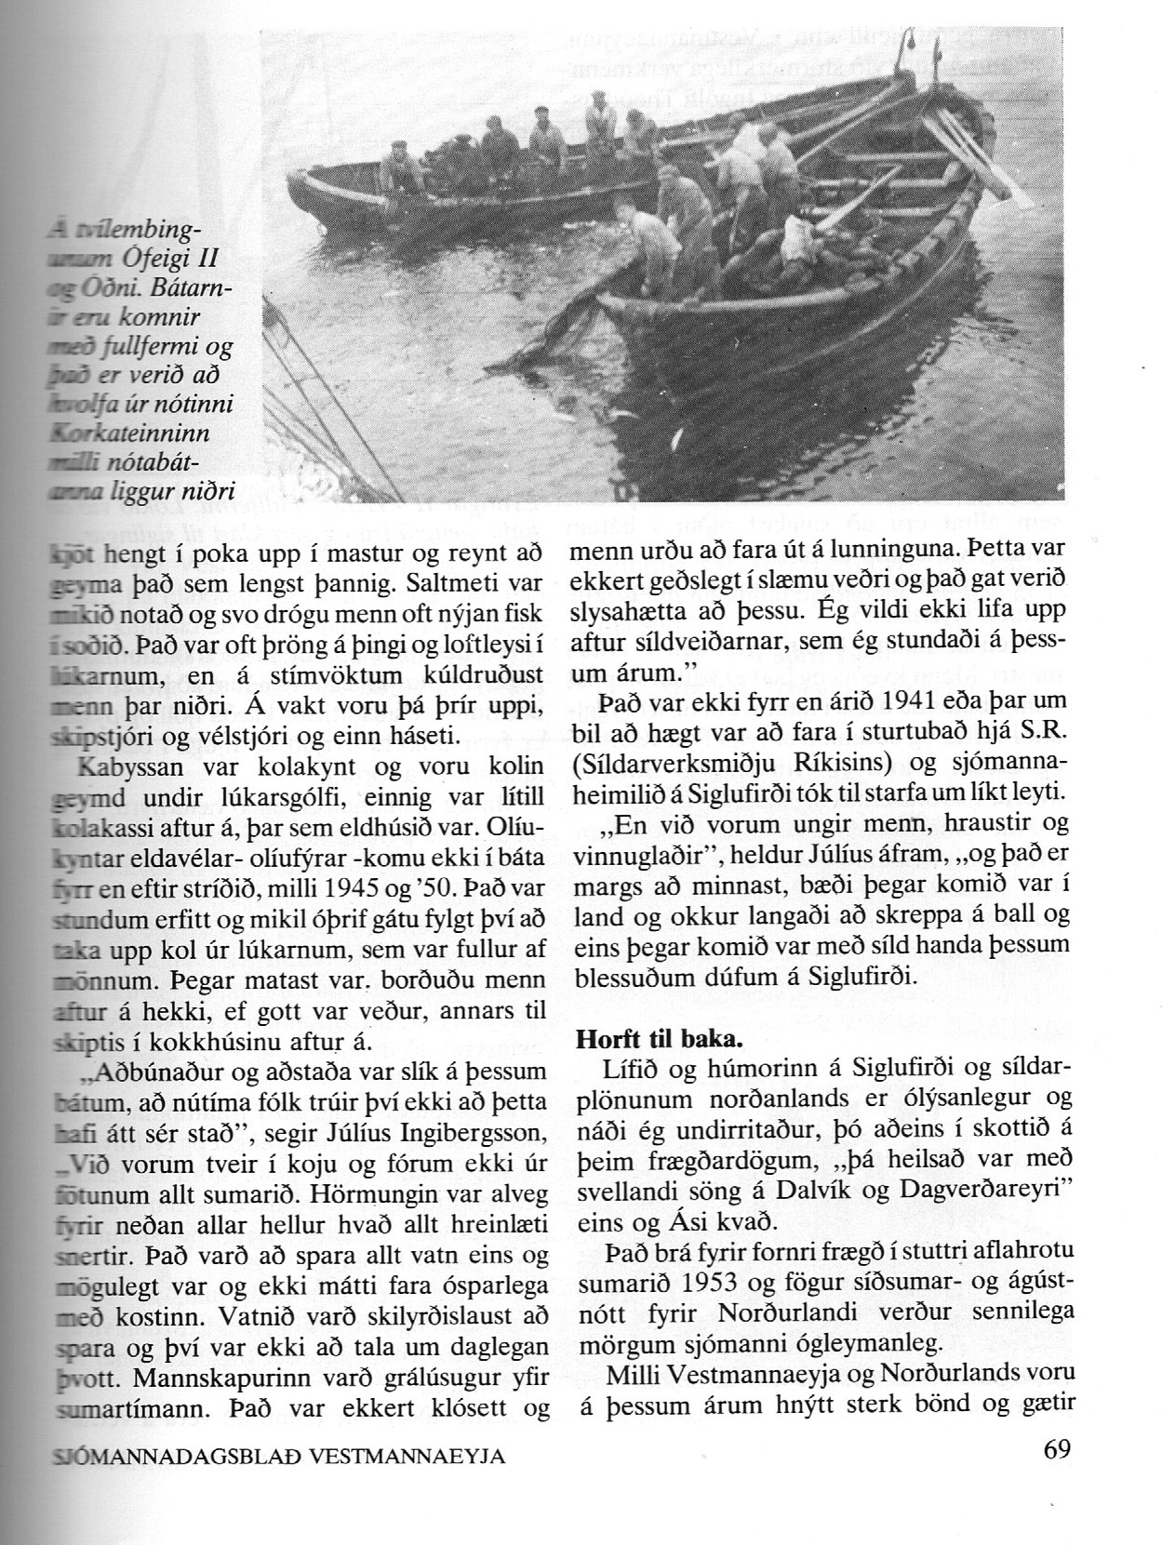

----------------------------------------------------16------------------------------------

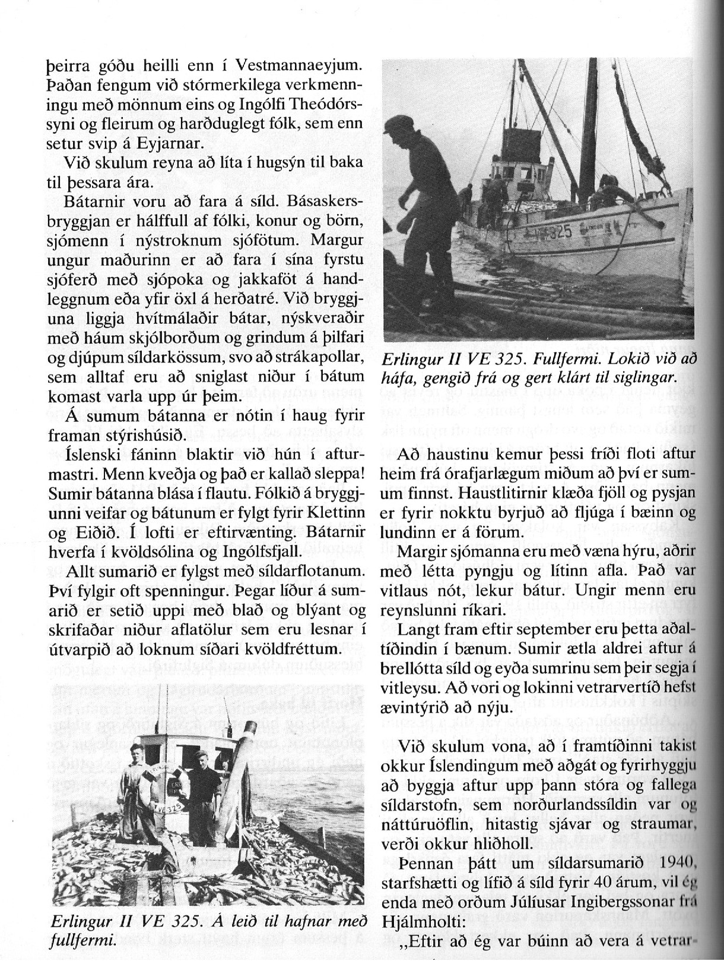

-----------------------------------------------------17------------------------------------------
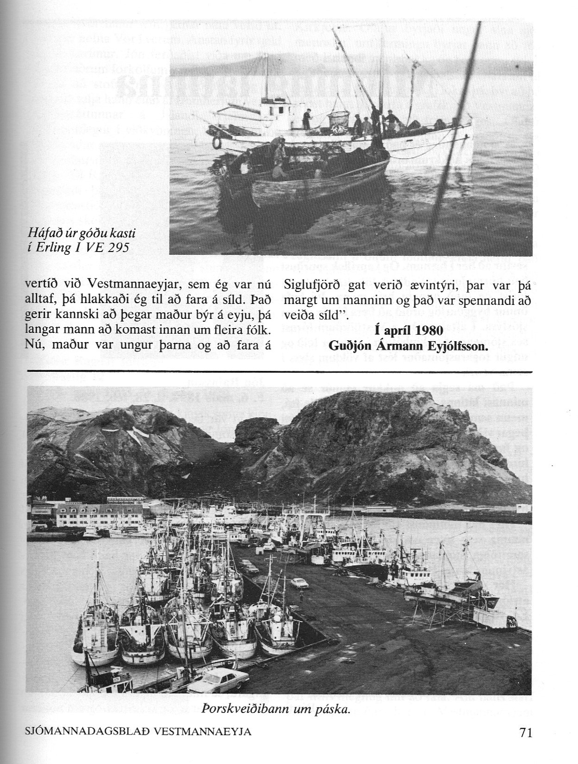

Tekið uppúr sjómannadagsblaði 1980.

